Rewinding the Cassette: A Look into the Revolutionary Music Production of Iran.
From Siahkal of the Caspian, Mountains of Kurdistan, and Iranian Student Movement Abroad.

By
Hasti Aryana Rostami

Undergraduate Honors Thesis
Submitted to the Department of Middle Eastern Studies
The University of Texas at Austin
May 2023

Supervisor
Dr. Mikiya Koyagi
Assistant Professor, Department of Middle Eastern Studies
Second Reader
Dr. Micheal R. Anderson
Associate Professor of Instruction and Department Director, Department of International Relations and Global Studies

For my father Omid and his love for music.
For Ahmad Rostami, Ali, and Mohammad Ali Khalegi, all students of the revolution from Mazandaran.
For the dear memory of my dayee jaans Iraj Bastani and Roohi Khaleghi.
For all revolutionary students of Iran and their love for music.

TABLE OF CONTENT

ACKNOWLEDGEMENTS 4
ABSTRACT 5
INTRODUCTION 6
Studying the Iranian Student Movement through Ethnomusicology 8
CHAPTER 1: FEDA’IAN, SORKHEH ROJA FROM MAZANDARAN 10
Sorkheh Roja 15
CHAPTER 2: CISNU, SHARAREH-HAYE AFTAB, IRANIAN STUDENTS ABROAD 21
Sharareh-haye Aftaab 34
CHAPTER 3: KOMALA, BANGEWAZ FROM KURDISTAN 50
Bangewaz 58
CONCLUSION 65

ACKNOWLEDGEMENTS
Foremost, I want to express my gratitude to my thesis supervisors, Dr. Mikiya Koyagi from the Middle Eastern Studies Department and Dr. Mihceal R. Anderson from the International Relations and Global Studies Department, for their unwavering guidance and steadfast involvement in every aspect of this research. This paper would not have come to fruition without their invaluable assistance. I am deeply grateful for their support and understanding throughout the past year.
I would like to thank Mr. Reza Yousef Beigi, vocalist and member of Bangewaz, for generously providing access to his collection of music, poetry, and past interviews. The materials shared played a crucial role in the documentation of the revolutionary music production of Rojhlat (Iranian Kurdistan).
I would like to express my gratitude to Dr. Benjamin Priest, from the Central Eurasian Studies Department of Indiana University Bloomington, for his invaluable contribution to this study. Taking Sorani Kurdish under his guardianship allowed me to better comprehend the Kurdish primary sources that I utilized in this research. Furthermore, Dr. Priest generously assisted me with translations of certain sources, for which I am immensely thankful.
I would also like to express my gratitude to Dr. Babak Tabbarraee, Program Coordinator of the Persian Program at the University of Texas at Austin, for his significant support and guidance throughout my academic career. Additionally, I would like to thank Dr. Nahid Siamdoust, whose teaching inspired and motivated me to pursue this thesis.

ABSTRACT
“Despite these fruitful achievements, thus far protest music as music, that is, not as lyrics, has only started to be analyzed in detail. Which role have musical means played in which contexts to support the activists’ expression of dissent?”
— Beate Kutschke, Protest Cultures: A Companion

There has been extensive scholarship on the historical occurrence of the Iranian Revolution of 1979 in relation to Marxism. The academic discourse around the subject has been studied through the disciplines of Islamism, Socialism, and public policy. However, there has been an area left completely untouched by the scholarly community: the music, specifically the cassette production of Leftist groups.
This thesis aims to present an ethnomusicological study of the Iranian student movement of 1979 with the objective of exploring the agency of cassette tapes, specifically focusing on recordings from Mazandaran, Kurdistan, and the Iranian students abroad and illuminate the role of music in the movement and its contribution in and out of context of Third World Internationalism.
Through an in-depth examination of the students' music production, the research endeavors to provide a unique perspective on the cultural and political significance of cassette tapes as a medium for political and social change during this period. Ultimately, the analysis seeks to demonstrate the originality of the music produced by the Iranian student movement, beyond its study within the context of the larger Third World Internationalism.

INTRODUCTION
The Pahlavi dynasty was established in 1925 when Reza Shah Pahlavi overthrew the Qajar dynasty and declared himself the new king of Iran. The dynasty was criticized for its authoritarianism and lack of political freedom. The opposition manifested itself in a short-lived Third World Socialism period at the peak of the Tudeh Party, the most influential Communist party in Iran during the 1940s and 1950s, after the abdication of Reza Shah and his replacement by his son, Mohammad Reza Pahlavi. What followed in the 1960s and 1970s were grassroots organizations of different Leftist political factions, with a particularly spirited scene in the universities and youth organizations across the country. Simultaneously, the wave of the Iranian student population studying abroad had found itself indulged in the New Left, also referred to as Third World Internationalism. The movement can be categorized as the political theory and practice which saw the major faults in the global capitalist order as operating between the advanced capitalist countries of the West and the deprived continents of Asia, Africa, and Latin America, and considered national liberation struggles in the Third World as the major force for global revolution. The narrative of Iranian students’ activism is primarily studied and examined in the context and framework of Third World Internationalism, while it is true that the Iranian students abroad were heavily in touch with the movement, it is vital to distinguish the agency and the distinctiveness of the Iranian student mobilization from the global movement. The music production of Leftists students of Iran carries a level of authenticity that is unique to the Iranian experience, and it is only the students abroad that rely on the New Left foundations.
The Iranian student organizers were involved in all areas of organizing; poetry, poster-making, and publications were just some methods used in opposition to the Pahlavi government. With the pervasive censorship on the radio and television, cassette tapes became a new medium of political dialogue of Leftist organizations. These cassettes contained music produced and composed by students and were circulated amongst the youth as a tool for raising political awareness and a call for revolution. The study of these cassette tapes is crucial as it pieces together an unwritten history of contemporary music in Iran.
This thesis is divided into three chapters, each focusing on a distinct music group, their associated political factions, and the social context in which they appeared. Chapter One is centered around Sorkheh Roja of Mazandaran with a brief history of guerilla resistance in the Caspian region. The primary sources of this band are limited as the band performed in the Mazandarani language and the majority of their music is not available in the domain, yet the folklore nature of the music remains unique of the Mazandarani culture and independent of the Third World Internationalist vision. Chapter Two is focused on where the Iranian story fits Third Word Internationalism; examining the Iranian students' rejection of the “imperial model minority,” the creation of the Confederation of Iranian Students National Union, their solidarity with other student organizations, and analyzing Sharareh-haye Aftab as its main cassette. Chapter Three focuses on the musical group Bangewaz and the Kurdish involvement in cassette and music production. This chapter endeavors to provide due recognition to the contributions of Iranian Kurdish revolutionaries, which have frequently been overlooked in the scholarly discourse in Iranian Studies. The chapter includes materials of Reza Yousef Beigi, vocalist and member of Bangewaz, a personal archive of poems, photos, and cassette tapes.
The ultimate objective of this study is to record the previously undocumented musical history of Iran, provide an analytical framework for the lyrics of the music, and employ ethnomusicology as a research methodology to comprehend the cassette production of Iranian students.

Studying the Iranian Student Movement through Ethnomusicology
In Protest Cultures: A Companion, Beate Kutschke offers a comprehensive and interdisciplinary examination of the various forms of protest and dissent that have occurred throughout history and the various factors that have contributed to their formation and evolution. Kutschke concludes that despite the ambiguity of music's role in political contexts, there are three main strategies for effectively utilizing it. First, the composer enriches the political message in a musical piece by incorporating clear verbal language, such as a text set to the music, a title, or commentary in the score. This is influential only if the title, commentary, and political message are known and understood by both the performers and the audiences. Second, the composer might choose to rely on the performance context to clearly articulate the political stance of the composition, and third, the composer chooses to use musical elements that are ordinarily associated with a certain mood or emotion to communicate a political message which can be utilized to support the existing political system or to call for change. Engaged composers tend to use music that is distinguished by tension and stimulates negative emotions to criticize the current state and advocate for change.
Kutschke argues that the efficacy of protest songs is largely defined by the associations that listeners make based on similarities between the song and other music, as well as contextual knowledge that shapes its “meaning.” The music production produced by the students movement of Iran in the 1970s fulfills the descriptions provided by Kutschke and this piece attempts to explain the “meaning” of the text to better understand the underlying tones and subgenres of cassette tapes produced during the Revolution of 1979. By analyzing the use of clear verbal language and studying the methods of political communication used in the cassettes, these chapters serve as an exploration of the underground cassette culture of the Iranian student movement.

CHAPTER 1: FEDAI’AN, SORKHEH ROJA FROM MAZANDARAN

Introduction to Organization of Iranian People's Fedai Guerrillas: In the Jungles of the North
The underground literature of the Organization of Iranian People’s Fedai Guerrillas describes the February 1971 launch of guerrilla armed struggle against the Pahlavi dynasty, in the Siahkal forests of Gilan province, as the “Siahkal Resurrection,” later remembered as the event that marked the beginning of the guerrilla era in Iran. Following Siahkal, the Organization of Iranian People's Fedai Guerrillas became one of the predominant opposition groups to Mohammad Reza Shah Pahlavi’s rule and sought the downfall of the monarchy through not just armed struggle but also the production of Marxist music and art, both abroad and in Iran, with deep roots in the Northern provinces of the Caspian Sea.
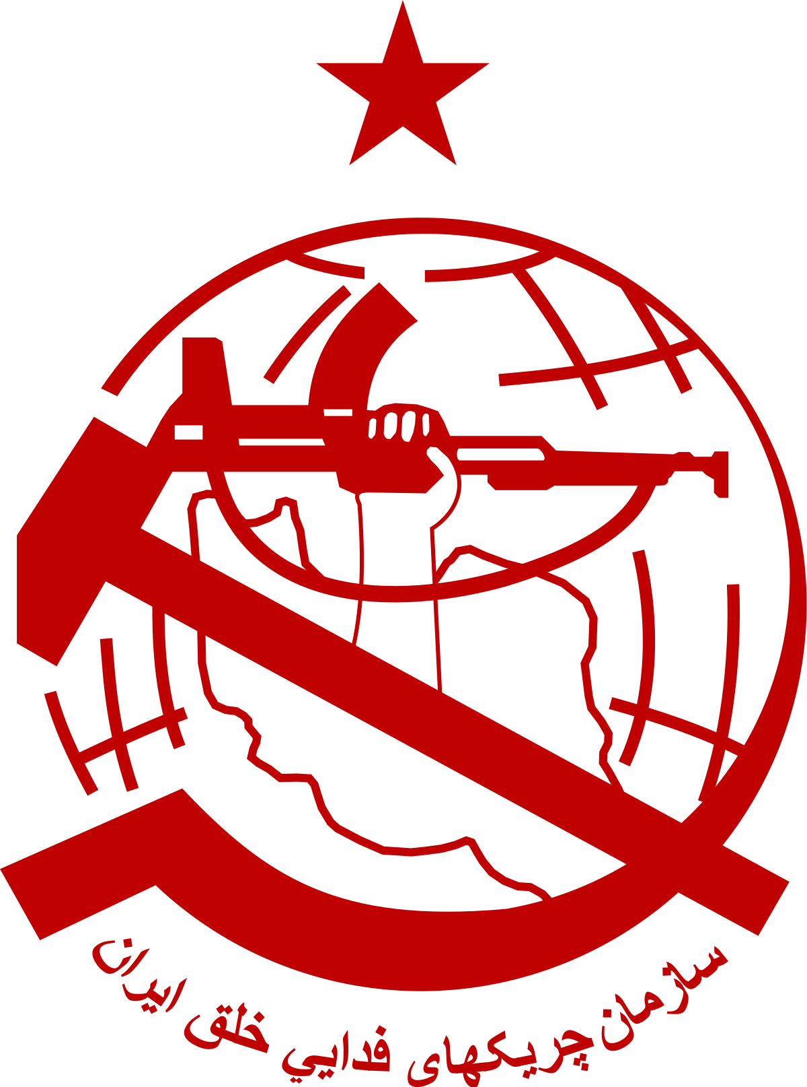
In April 1971, the Organization of Iranian People's Fedai Guerrillas was established when the Jazni-Zarifi and Ahmadzadeh-Pouyan-Meftahi guerrilla groups merged. The first group, with indirect links to the Tudeh Party, and the second, stemming from the Second National Front, a political alliance formed in the 1950s, consisting of various Leftist and Nationalist parties. Fedai Guerrillas’ organization gained notoriety for the staunch defense of its armed tactics, notably in its involvement with the Siahkal operation. The two groups, the Jazani-Zarifi Group (later referred to as Group One) and the Ahmadzadeh-Puyan-Meftahi Group (later known as Group Two), came together during an attempt to resurrect political action in the face of repressive conditions, giving rise to what became known as Feda’ian.
Before delving into their history, it is important to establish the origins of the two groups. Hassan Zia Zarifi was born in the Caspian town of Lahijan in 1939. As a Tudeh supporter, he was first arrested in 1956 but released shortly after, later on, Zarifi enrolled as a law student at the University of Tehran and assumed a leadership role within the National Front Student Organization. From 1960 to 1963 where he encountered numerous arrests for his participation in student demonstrations. By 1965, Zarifi had been introduced to and had become a member of Group One's Central Cadre (Kadr-e Markazi) and there he became acquainted with Abbas Surki, who was previously attained in 1960 for establishing an underground group known as the Warriors of the Tudeh Party (Razmavaran-e Hezb-e Tudeh). In the following year, Group One concluded that the land reform efforts had reduced the revolutionary potential of the rural population. Therefore, they diverted their attention to the urban areas, which they believed would provide a better ground for their armed movement. A summary of these discussions that took place during the mid-1960s was later published as the Thesis of the Jazani Groupe, making it the first document to be released publically. Between this time and the 1971 Siahkal operation, group members produced three rural studies, each the length of a book, which examined land reform, agricultural corporations, and Caspian fishermen, as well as essays on the 1953 coup, the party, and unity. Furthermore, they authored two book-length treatises. What a Revolutionary Must Know (Safai Farahani 1976), which was attributed to Abu-Abbas-Ramas (Safai Farahani’s alias in Palestine) and backdated to 1969, was issued and distributed following the authority raids that occurred in the summer of 1970. At this stage, Group One had made contacts with other anti-imperialist movements in the Middle East. Some members of the Jazni-Zarifi later joined the Palestinians, and Safai Farahani trained and later commanded a post in George Habash’s People’s Front for the Liberation of Palestine. The seeds for an armed attack were growing and the only absent component for its actualization was a cohesive coalition.
The roots of Group Two can be traced back to the Second National Front, which was established in the city of Mashhad, the birthplace of Massoud Ahmadzadeh Heravi and Amir Parviz Puyan. Puyan relocated to Tehran in 1965 to attend the Faculty of Social Sciences at the University of Tehran. Ahmadzadeh also relocated to Tehran in 1967, to pursue a degree at Ariyamehr Industrial University. The third member of the group, Abbas Meftahi was a native of Sari, the capital of the Mazandaran province by the Caspian Sea. While studying at Sari Technical School in 1962-63, Meftahi was first oriented towards Marxism by his instructor, Safai Farahani, he later moved to the country’s capital and enrolled at the School of Technology at the University of Tehran. Like other universities of the time, all these campuses had active student engagement in anti-government activism and it is generally thought that in the winter of 1968, Ahmadzadeh, Puyan, and Meftahi, vowed to launch an underground militant organization. However, this narrative has also been disputed, arguing that only Puyan and Meftahi founded the group at first. Nonetheless, the three of them became the main committee members and began searching for reliable individuals to bring into the group. Although almost all of their recruits were university students, the group did not show much interest in student activism and instead focused on systematically studying Marxism-Leninism. The group also diverted its view on the assessment of Iranian society as semifeudal-semi-colonial, rejecting the Maoist perspective, and initiated the study of revolutionary literature from Latin America. Group Two's lack of roots in the Iranian Marxist tradition had its benefits, as it nourished the group with theoretical flexibility instead of being bound by entrenched dogmatism. At the beginning of 1970, the group ultimately came to the conclusion that armed conflict was the sole way to achieve political influence in Iran. Puyan's argumentative essay, titled The Necessity of Armed Struggle and the Rejection of the Survival Theory, served as a compelling summary of the group's inner discussions.
The Caspian region was selected by the group for their first operation. The group's decision to launch guerrilla warfare in the region was based on their assessment of the region's “revolutionary potential,” asserting its politically conscious population and previous Marxist tendencies would allow for such an operation to be successful. Thus, “the revolutionary potential” found itself in Sihakal, on 8 February 1971, the groups staged an armed attack on the military base in the town of Siahkal, in the forest region of Gilan province. Thirty militiamen and several of Mohammad Reza Shah’s guards were killed; of the revolutionaries who died, twenty-nine were executed and one died under torture. Yet the attack was faced with favorable discourse amongst Marxist groups; concerning the significance of the attack, Vahabzadeh explains “The legendary narrative of Fadaiyan placed the operation in a socially tangible heroic discourse and gave birth to a popular term, rastakhiz Siahkal (the Siahkal Resurrection).” Following the execution of the Siahkal guerrillas, Group Two carried out small operations while Group One assassinated Lieutenant-General Farsiu in retaliation for the execution of their members. By April 1971, both groups gained a consensus on having a shared ideology and the Organization of Iranian People's Fedai Guerrillas announced its emergence through thirteen popular communiqués. The first communiqué reads:
“Where there is oppression, there is resistance. . . . We are the children of the toiling masses who taught us how to achieve freedom and a decent life by shedding their blood in the past hundreds of years. . . . Guerrilla warfare has now begun. . . . The heroic assault of self-sacrificing guerrillas on the Siahkal Post in Gilan clearly shows that armed struggle is the only path to the freedom of Iranian people. By attacking the Qolhak Police station and execution of the murderer [General] Farsiu, we, People’s Fadai Guerrillas, have shown that we would continue the heroic struggle of Siahkal.”

It is apparent that Siahkal became the symbol of Feda’ian, constantly mentioned in every publication of Kar and the Marxist poetry of its members. With the new wave of turmoil in Iranian universities, the organization emerged to find itself encountered with the key question of its generation: activism. Activism blossomed in publications, poster-making, and notably music-making, and cassette circulation.

Sorkheh Roja
During the 1960s, Sorkheh Roja (The Red Star) first appeared as a Leftist publication in the Caspian region of Iran, linked to the Organization of Iranian People's Fedai Guerrillas, the publication provided critical criticisms of the Pahlavi policies and its administration, alongside theoretical writings on Marxism and the history of Socialism. Notably, Sorkheh Roja was renowned for its militant and radical perspective, which subsequently led to its prohibition by the Pahlavi government. Sorkheh Roja also engaged in dialogue with other Marxist publications, one instance of critique emerged after the release of “Interview with Rafiq Ashraf Dehghani,” when Sorkheh Roja, unfailingly supportive of the organization in Mazandaran, voiced their opposition,
“The struggle for freedom of unions and political parties should not necessarily pass through the channel of overthrowing the bourgeoisie. Perhaps for years, a dependent bourgeois rule may exist, and we, for example, should lead the struggles of workers for a 40-hour workweek or the freedom of labor unions.”

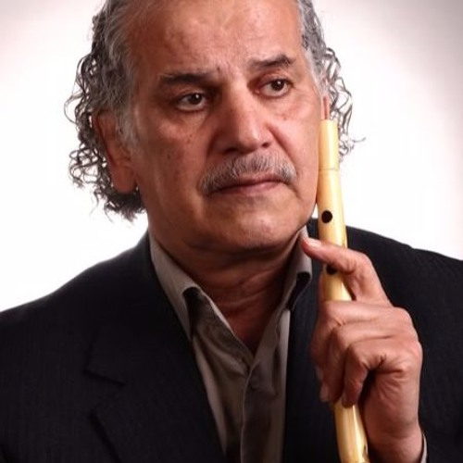
Alongside the publication, in 1960, a musical ensemble was also established, featuring the collaborative efforts of Farajollah Khoshrou on the Santur, Abdolhassan Khoshrou on the Kamancheh, and Ahmad Mohsenpour on the violin, and Lale Va, the traditional Mazandarani flute. Their partnership began with the provincial radio station of Mazandaran in 1966. Subsequently, with the establishment of the Sorkheh Roja music group and their album “Star of the Morning” in 1971, Khoshrou diversified his artistic pursuits. Additionally, he carried the role of supervisor for the Amir Pazvari group and became well-known for his performances as both a singer and a musician in the Lava style within the central region of Mazandaran. The success of the music group can be attributed to the influential contributions of its two predominant members, namely Abdolhassan Khoshrou and Ahmad Mohsenpour.
Abdolhassan Khoshrou, a renowned musician in Iran, was known for his distinctive style of blending traditional techniques with his personal touch in his performances of Lilijan and Mazandarani songs. This distinction set him apart from other musicians, and his artistic works and activities have had a significant impact on the evolution of Mazandarani music. For this, he became known as the “symbol of Mazandarani music” and the “Shajarian of Mazandaran” in scholarly discourse. Mohammad-Reza Shajarian’s innovative approach to integrating traditional techniques with his personal style in his music has made him an inspiration to many other musicians in Iran, including Abolhassan Khoshrou. Hence, Khoshrou has been compared to Shajarian due to his innovative traditional approaches and profound influence on Mazandarani music. After the revolution, Khoshrou, who was working as an art instructor in the schools of Mazandaran, was instantly expelled and detained from work after the seizure of power by the clergy. He was faced with imitations in advancing his artistic work and never performed political songs in public.
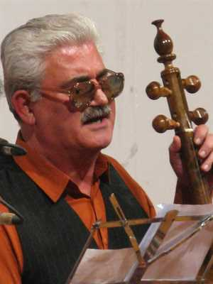
Ahmad Mohsenpour, the other half of the production, who was visually impaired and acted as the main composer of the group. In 1974-75, he joined the local radio group in Sari, and in 1976 became a member of the Mazandaran National Orchestra of Culture and Art. Later, in 1978, he became the head of the local music group at the Department of Culture and Arts, a position which he held until 1979. After the arrests of Sorkheh Roja members in the aftermath of the revolution, Mohsenpour was compelled to produce music under the restrictions imposed by the government. Regrettably, the limitations on his artistic expression persisted until his death in 2016.
In partnership, Mohsenpour and Khoshrou produced cassette tapes featuring traditional Mazandarani folklore aimed at bolstering the guerrilla movement. In the present chapter, a selected piece has been analyzed and translated with the aim of comprehending the underlying messages and meanings conveyed within their lyrics.
Mashti
The story of Mashti is one of history and folklore. Originally sung by the people of Dodangeh, Chahardangeh, and Savadkuh regions, this type of poetry recitation was dominant in Tabarestan for warriors, brave people, and heroes, which are referred to as “Soot.” Mashti Pelveri was a rebellious figure during the definitive years of the Qajar dynasty and the early Pahlavi era. Some consider him a rebel (in Persian yaghi), and others see him as a fighter against Reza Shah. It is important to note that the term “yaghi” in the Mazandarani language and culture refers to an individual who stands up against oppression and inequity by the ruling authorities, who are typically either the central government or their elected representatives in the region. In the culture of Persian-speaking regions of Iran, individuals with such characteristics were referred to as “ayyar.” For instance, in various poems of Mazandaran and Gilan, individuals such as Mirza Kuchak Khan, Hejabr Sultan, and Eshghali Yaghi were labeled as “yaghi.” This insight is pertinent to understanding the identity and actions of Mashti Pelveri.
Sorkheh Roja produced a 17-minute-long track dedicated to Masthi, in the beginning, they make notable mentions of the “movement in the Jungle of Gilan” and state “the yaghis who were aware of the class struggle had found a sense of righteousness in themselves chose to seek justice.” Portions of the lyrics of Mashti are conveyed in the Mazandarani language and subsequently translated into English, as depicted above.

مشتي بئيه عصباني
بته رفيقون سنگسري
مير غفار و مير هادي
مير غفار و مير هادي
Mashti is angry,
His comrades from Sangsar,
Mir Ghafor, and Mir Hadi,
بشكندين دره كلي
نكنين بي حرمتي
نكنين بي حرمتي
صندوقچه فولادي
بشكندينه ونه كلي
اسكناس دسته بندي
بسته بسته پن زاري
You broke the valley,
Don't be disrespectful,
The steel box,
You broke it all,
Sorting the money,
Counting them one by one,
همه ره بئيته مشتي
پخش هاكرده بين محلي
پخش هاكرده بين محلي
امان از دست مشتي
امان از دست مشتي
All the way,
Mashti is with us,
Distributing it among the locals,
Beware of Mashti's wrath!
Beware of Mashti's wrath!

The lyrics of the song depict Mashti as a figure who takes it upon himself to seize all the money and distribute it among the farmers and the public. The lyrics carry a tone of caution, urging individuals to be wary of Mashti's potential for retribution as he relentlessly seeks to right the wrongs committed against those who are disadvantaged.
From analyzing the track of Mashti, it is evident that the distinctiveness of Sorkheh Roja's music stems from its firm commitment to the indigenous music and folkloric traditions of Mazandaran. This musical form remains unassociated with Third World Internationalism and retains its autonomy and independent character vis-à-vis this movement. The music production of Sorkheh Roja, a collection of Mazandarani folk songs, was developed to convey the distinct Mazandarani identity amidst the politically charged environment of its time, while simultaneously praising the guerrilla efforts.
This genre of music is unequivocally exclusive to the cultural heritage of northern Iran and remains separated from the larger context of the Third World Internationalism movement. To elaborate on this further, the music production of Iranian students abroad during the same period was characterized by a blending of elements of Third World Internationalism with the incorporation of original text and lyrics, thus creating a unique musical identity. This approach stood in contrast to the music produced by leftist groups within Iran, which, as previously noted, were independent of larger international movements.

CHAPTER 2: CISNU, SHARAREH-HAYE AFTAB, IRANIAN STUDENTS ABROAD

Iranian Students in Europe: First Wave of Student Immigration Abroad
Abroad, the story of cassette production can be studied through the student movements’ connection to the vision of Third World Internationalism. In France, like in Iran, as Mosaddeq rose to power, pro-National Front students and especially Third Force socialists began to form a competing group. Since the early 1950s, an Iranian Students’ Society had existed in France, and it mainly drafted sympathizers for the Tudeh Party. National Front supporters also demanded elections for the Iranian Students’ Society, which eventually were held in 1952. There was an eventual split by the other faction, which lead to the establishment of the rival Union of Iranian Students in France (UISF). The rival faction of non-Tudeh students in France was officially established on June 21, 1952, and registered in Paris. The objectives of the group, as outlined in its constitution, were concentrated on academic quests and cultural interactions and excluded political and religious matters. The objectives were to protect the academic interests of Iranian students in France, broaden connections with other Iranian students abroad, and promote mutual arrangements between Iran and France. This constitution's structure and vocabulary indicate that certain students possessed prior experience in organizational matters, a fact which later qualified them to establish the Confederation of Iranian Students (CIS) with a strong footing.
In 1958, a shift transpired in the activities of students in France. To bring back the inactive Union of Iranian Students, twelve members assembled and chose a five-person leadership board. Finally, contacts were made with Iranian students in Austria, Belgium, Britain, Italy, Switzerland, and West Germany. The concept of connecting Iranian students across various countries in Europe was first presented by Name-ye Parsi (Persian Letter) in May 1959, and it began publication as a forum for all Iranian students in Europe. The first was published, an editorial, “Towards Unity and Solidarity,” which pointed out that there were over 7,000 Iranian students studying in Europe, and stressed the essence of unifying them to advance their collective and national interests. In its third issue, the publication claimed that student organizations should not just focus on their own interests or the ones of corporations, but rather have a say in shaping national policies for higher education.
The formation of a second major branch of the Confederation of Iranian Students in Europe was established in England, where a few Iranian students had started studying at universities such as Birmingham in the 1920s. Later, in 1958, the new leadership opposing the embassy-tied association the Society of Iranian Students in England aimed to extend the autonomous London Society and established a federation of Iranian student organizations in England, along with launching a series of student publications. Prior to and during the formation of the Confederation of Iranian Students in Europe, an expansion in journalistic endeavors took place among Iranian students in the United Kingdom. The Society of Iranian Students in England began assembling a monthly journal called Pazhuhesh (Inquiry) in 1957-1958 followed by the creation of the Federation of Iranian Student Societies in April 1960, just prior to the establishment of the European CIS in Heidelberg. From 15th to 18th April 1960, delegates from Iranian student groups in Germany, France, and the United Kingdom gathered in Heidelberg, West Germany, to merge their organizations and establish the Confederation of Iranian Students in Europe. Two years later another conference was held, where the branches in Europe united the student chapters in the United States and founded the Confederation of Iranian Students National Union.
Iranian Students in the United States: The Racial Dynamics of Cold War Integration
Paul Kramer explains the invitation of foreign students in the context of the politics of the United States after World War II, where the government agencies and educational institutions considered foreign students to be “critical actors in the global politics of the Cold War and decolonization” and “prospective agents of US influence in the world to which they would eventually return.” Under this condition, Foreign students were granted higher education and propelled towards modeling “universal human benefits” that were offered by the United States in exchange for future skilled labor and establishing relations with their home countries. This can be seen as “imperial model minorities,” related to the domestic “model minority” concept, both created during the era of the Cold War and sought to integrate non-white individuals into the narrative of American superiority and exceptionalism, though at different geographical levels. The domestic “model minority” was utilized to disguise the systemic oppression that still existed after civil rights legislation. Meanwhile, the “imperial model minority” was deployed to erase and suppress the adverse consequences of modernization leading to economic polarization and state-sponsored repression in Third World nations that were allied with the United States. Thus, to the United States’ interests, the foreign student population embodied what Lisa Lowe, a scholar of ethnicity, race, and migration once identified as “abstract citizens,” an entity unmarked in the eyes of official national culture and politics by anything that would mitigate being a voter and a free agent in the capitalist market. Lowe demonstrates that in a multiracial country like the United States, the interests of capital and the state may conflict. Capital, with its presumed necessity for “abstract labor,” is, according to Marx, apathetic to the “origin” of its labor force. In contrast, the United States requires “abstract citizens” who are united by culture to partake in the political arena and are keenly concerned with conserving a national citizenry that is tied together by race, language, and culture. Lowe writes,
Abstract labor, subject to capitalist rationalization and the logic of equivalence through wages, is the adjunct of the formal political equality granted through rights and representation by the state. Yet in the history of the United States, capital has maximized its profits not through rendering labor “abstract” but precisely through the social productions of “difference,” of restrictive particularity and illegitimacy marked by race, nation, geographical origins, and gender.
The ability to perceive the difference as abstract, whether it's through color-blind constitutionalism, claims of gender neutrality, or pleas to objective selection criteria, serves as a solution to illegitimate forms of discrimination. Thus, the depiction of certain minority groups as “model minorities” due to their perceived relative economic success in the United States media was used to contradict the strong critique of systemic inequality and racism by the civil rights and Black power movements. The Iranian “imperial model minorities” were endowed access to higher education institutions that primarily excluded racialized Americans and provided them with proximity to the advantages associated with being deemed “white.” While higher education was intended to incorporate the “model minority” citizens into American culture, Iranian “imperial model minorities” were expected to promote Americanization in Iran's economy, politics, and culture. Whereas Iranian foreign students were perceived as crucial in bringing Iran into the “free world,” they were not consistently categorized based on outdated European views of the “West” and “East” as opposing forces. Instead, they were included in the conflicting concept referred to as “Cold War Orientalism” by Christina Klein, which frequently emphasized the idea of friendly relations between the East and West rather than competition. The integration of Iranian foreign students into the United States' idea of advancement in the Middle East demonstrated the Cold War Orientalism view of the Eastern “other” as being understanding and approachable. This alongside the fact the majority of Iranian students were men from affluent families further reinforced the goal of training prospective leaders of “capitalism in the Third World.”
Throughout 1950-1970, tens of thousands of Iranians were enrolled in colleges and universities across the US and Europe, more foreign students than from any other country. The arrival of Iranian foreign students in the United States coincided with the peak of what Mary Dudziak referred to as “Cold War racial liberalism”, a system of racial tolerance aimed at improving the United States’ image internationally by addressing the criticism it faced over its treatment of racial minorities domestically. As symbols of American exceptionalism and sponsorship, Iranian students embodying the “imperial model minorities” became part of the post-World War II effort to incorporate racial differences, yet the classification of the “imperial model minority,” like that of the “model minority” citizen, was often overshadowed by the contradictions it was intended to eliminate. In the process of recruiting and educating “imperial model minorities” as explained by Kramer,
“Selection, diffusion and legitimation, while devoutly hoped for, sometimes spilled off the rails, when screenings failed to prune student radicals and dissenters, when students' lateral solidarities overtook hoped-for vertical loyalties, when students' encounters with the U.S. state and civil society proved alienating rather than binding.
There was the Nkrumah problem, when foreign students developed into radical, anticolonial nationalists. There was the Qtub problem, when a visiting educator discovered in one's society a religio-political enemy with whom no exchange could be suffered.”
In the process of cultivating the optimal “imperial model minorities” out of Iranian students, the student population took possession of the narrative. The Iranian Students Association in the United States (ISAUS) was established in 1952 in Madison, Wisconsin by the Iranian Embassy and the American Friends of the Middle East (AFME). Although AFME was created in 1951 as a supposed “philanthropic” administration to better relations between the United States and the Middle East, it served as a “front” funded by the CIA's International Organizations Division to compete with the Soviet Union for control over international labor unions and student groups. The AFME and the Iranian embassy directed the activities of ISAUS in support of the Pahlavi government. They covered the travel expenses for ISAUS's annual conventions, where a five-member “Secretariat” known as hey'at-e dabiran was elected to lead the organization. The pro-Pahlavi orientation, therefore, prevailed in the ISAUS throughout the 1950s. For instance, during Mohammad Reza Shah’s 1958 visit to the United States, he was elected honorary chairperson of the ISAUS. Despite this, opposition forces gained momentum in the late 1950s as the political landscape in Iran shifted, and American universities evolved more intertwined with the Third World Internationalism vision. At this time, two separate Iranian student publications emerged: Iran Nameh in New York and Pendar in Cambridge, Massachusetts, yet the student narrative was still largely in the hands of ISAUS.
The eighth annual convention of ISAUS, carried in Ypsilanti, Michigan from August 29th to September 2nd, 1960 marked a crucial point in the politicization of the organization. Around 170 students from 25 states participated. Although opposition activists were in contact with each other, they lacked organization and did not have a clear plan to take over. A committee was then designated to write a revised ISAUS constitution. Unexpectedly, opposition activists had gained the upper hand. Later, the ISAUS Congress of 1960 called for a foreign policy of “positive non-alignment,” based on the common conditions shared with Asian, and African states and members of the Bandung Conference. Gradually the student population of ISAUS leaned more towards Leftist politics and in January 1962, with official endorsement from the Organization of Tehran University Students, CIS, and ISAUS merged to form CISNU, which proclaimed itself as the “National Union” of students in Iran and abroad,
Towards Global Contention: Confederation of Iranian Students - National Union

“However incredible this task may appear at present, let us have as our goal for 1962 the creation of one National Union of Iranian students.”
— Paygah, vol. I, no. 3, December 1961, p. 2.
Just over two years after the initial formation of the Confederation of Iranian Students (CIS) in Europe and the Iranian Students' Association in the United States (ISAUS), the two students organizations joined and the Confederation of Iranian Students National Union, was established in January 1962 in Paris, France. Endorsed by the Organization of Tehran University Students, the CISNU promoted itself as the representative of Iranian students abroad and in Iran. The student organization started to have large congress meetings in Frankfurt, Germany, where delegates and representatives of different university chapters across the United States and Europe met annually to pass resolutions, talk of different political publications, organize protests, and stand in solidarity with other political organizations across college campuses.
The CISNU included students that identified with multiple different political groups in Iran, in the 1960s the majority of the students’ political associations and ideologies were split between the Tudeh Party and the National Front of Iran, and by the 1970s the Organization of Iranian People's Fedai Guerrillas, People's Mujahedin Organization of Iran, the Organization of Struggle for the Emancipation of the Working Class (Peykar), Labour Party of Iran (Toufan), and other smaller Marxist groups made up the student body population of the Confederation. Though some students were already affiliated with these different Iranian political groups, it was the exposure to global struggles that pushed the students toward Leftist politics with hopes of an end to what they perceived as Iran under the fists of Western Imperialism.
The creation of CISNU as well as its political alignment with other international Marxist groups was an introduction to the Iranian struggle to global Third World Internationalism. The global movement sought to unite the peoples of the “Third World” (a term used to describe those countries that were not aligned with either the North Atlantic Treaty Organization of the capitalist First World or the Warsaw Pact of the communist Second World) to challenge and resist the economic, political, and military power of the “First World” and to assert their independence and self-determination. The CISNU played a significant role in the radical youth and student movement in Europe and the United States and supported international causes such as Cuba, Vietnam, Palestine, and South Africa. In terms of size, longevity, and influence, the Confederation outperformed its more well-known counterparts, such as the Students for a Democratic Society in America and the Sozialistischer Deutscher Studentenbund in Germany.
The movement was characterized by anti-imperialist and anti-colonialist sentiment, and it aimed to promote solidarity and cooperation among the peoples and nations of the Third World in their struggles against colonialism, neo-colonialism, and global inequality it was during this political climate that CISNU made its first introduction to student organizing groups all around Europe and United States campuses. During the 1960s and 1970s, when US support for authoritarian dictatorships was a major Cold War strategy in the fight against communism, and it was common practice for leftists to condemn these alliances all in one breath, with CISNU at the forefront of the fight.
The following passage is from a report of CISNU’s Ninth Congress in 1969:
Demonstrations of American students against that country's aggressive war in Vietnam, the uprising of French students against the reactionary educational system and total capitalist domination, and the struggles of German students against fascism and their government's imperialist policy, (these) are all sparks that will turn into a great fire earning the destruction of world imperialism.
Iranian students abroad saw themselves as part of a “global contestation,” where the protest movement in the West, led by students and young people, allied with revolutionary movements and wars of national liberation against imperialism happening globally. By the late 1960s, the CISNU and its leftist and Marxist allies were staging larger and more militant protests in Europe and the United States when the Shah, members of the royal family, or high-ranking Iranian officials were visiting. In May-June 1967, a significant confrontation in Germany demonstrated the influence of Iranians on the European student movement. In response to Mohammad Reza Shah's visit to West Berlin, the leading German student organization, the Sozialisticher Deutscher Studentenbund (SDS), joined forces with the CISNU to mobilize for demonstrations. Between 1962 and 1979, the organization oversaw thousands of students partaking in cultural activities, demonstrations, and other acts of protest aimed at exposing the oppressive rule of the Shah and the involvement of Western nations. Based in the West, CISNU adopted a stance that rejected both Western liberalism and Iranian nationalism and instead aligned with radical student groups opposing capitalism and colonialism.
All the activities of CISNU were in function with other Third World internationalist student movements. CISNU played a key role in supporting the Palestinians, who were close allies of Iranian students. CISNU and the General Union of Palestinian Students (GUPS) regularly sent representatives to each other's congresses and worked together on various initiatives. Additionally, CISNU leaders viewed the targeting of Palestinians as the start of a conservative effort to tighten control over foreigners and German radicals. As a result, CISNU declared that it would resist the attack on Palestinians as if it were an attack on the Confederation itself. In 1967-68, a considerable number of Iranian students in Europe and the United States voiced their feeling of “alienation” from and opposition to the dominant power structures in developed industrialized nations and their practices of economic exploitation, and imperialist military intervention in other parts of the world, particularly in Vietnam with CISNU publishing multiple materials on the Vietnamese struggle. One of the publications, Bulletin, which was created to keep all members of the Confederation of Iranian Students in Europe informed about the organization's activities worldwide, contained several favorable references to the Vietnamese. The organization also actively exchanged solidarity messages with Cuban and Algerian student organizations.
The 1960s for Iranian students abroad marked an introduction to international decolonization and anti-imperialist struggles, while the Western movement reached its peak in 1968, CISNU had only started to get stronger in its grassroots efforts, yet faced internal conflicts within the organization. The divisions within the Confederation that ultimately led to its split were due to various factors. Firstly, the National Front (NF) bloc included the Kargar group and the National Front Organizations in the Middle East (NFME). In 1972, the Kargar group, which did not endorse a guerrilla approach, officially separated from the NF organizations abroad. The NFME initially supported the guerilla movement, but discrepancies with them grew by the mid-1970s. Meanwhile, Iran-e Azad, the publication of the NF organizations in Europe, expressed strong pro-guerrilla and Marxist views. Second, the Maoist bloc, consisting of Tufan and the Revolutionary Organization of the Tudeh Party (RO), claimed that the NF faction was hostile towards true revolutionaries, i.e., supporters of China, and had instead grown closer to the Tudeh Party. In reality, by 1974 the Tudeh Party had lost all interest in any collaboration with the CISNU and had formed its student group called the Organization of Democratic Youths and Students of Iran (ODYSI). The third significant group within the Confederation of Iranian Students in Europe was composed of supporters of the Organization of Communist Revolutionaries (OCR). This group became the predominant faction in the ISAUS during the 1970s, after the demise of the RO. Although the OCR pursued Maoist principles, it varied from the RO and Tufan in its agreement with the National Front bloc on incorporating the demand for the overthrow of the Pahlavi government into the CISNU charter. Most importantly, for the first time since the early 1960s, opposition in Iran was active and organized.
The guerrilla armed struggle had a radicalizing influence on the student movement both inside and outside the country, guiding all opposition groups to reexamine their positions in light of this new revolutionary threat. Therefore, after 15 years of active operation, a united CISNU ceased to exist as a unified organization by 1975. Nevertheless, this did not mark the end of organized Iranian student resistance abroad. In fact, from 1975 to the start of the revolution in 1978, the student opposition intensified and had a greater impact due to the combined efforts of the various organizations that had split from CISNU. Third World Internationalism gave momentum to the Iranian student movement abroad, yet the seeds did not flourish until a decade later. What came from this level of international organizing can be seen in the protest music and cassette tapes of CISNU, these cassette tapes include mentions and ties to the Third World International movements and included songs of other international struggles. Despite the 1975 split, Iranian students abroad continued their organizing in all creative manners, and it was at the University of Washington’s CISNU chapter where Sharareh-haye Aftaab was born.

Sharareh-haye Aftaab
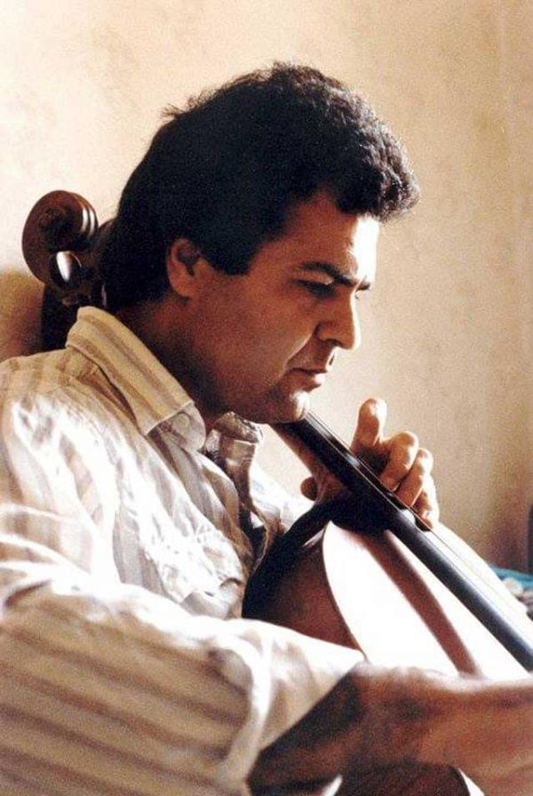
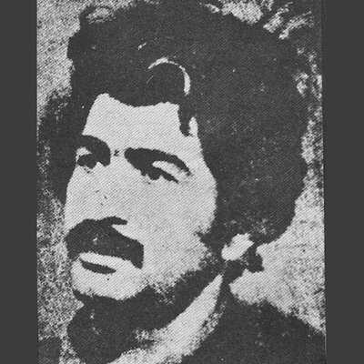
Sharareh-haye Aftaab was recorded approximately two months before the Islamic Revolution of 1979. The cassette tape includes twelve tracks, seven of which were all written by Saeed Soltanpour while he was a political prisoner under the Pahlavi power. Soltanpour was a member of the Iranian Writers Association and one of the engaged poets in Goethe's Poetry Nights. He was a student of theater and studied at the College of Fine Arts of Tehran University and was an active Leftist in opposition to the Pahlavi government. In 1968-69, he published a series of his poems in his book Sedayee Mira which was immediately seized and banned by SAVAK, the secret police of Mohammad Reza Shah. SAVAK forces created a legal case against Soltanpour
for being a “dangerous artist.” In the following year, he was involved in the theater production of the play En folkefiende (An Enemy of the People) by Henrik Ibsen. On the 11th night of the show, SAVAK forces raided the theater and halted the production. SAVAK forces shut down numerous other of his theater shows, and he was apprehended several times serving time in the Ghezel Ghaleh and Evin prisons. Following the staging of the play Amozgaran/Teachers by Mohsen Yalfani in 1970, Soltanpour was subjected to a raid by agents of SAVAK, which resulted in the forced closure of the play. Two years later, Soltanpour faced allegations of his association with the Organization of Iranian People's Fedai Guerrillas as well as being suspected of having Marxist sympathies. As a result of these charges, he was sentenced to a five-year confinement term, which he served in its entirety. From 1972 to 1974 he was repeatedly arrested and finally jailed for publicizing his poems Avaaz-haye Band, which were written during his time in prison. The poems that were written by Soltanpour in his solitary confinement became anthems that preached freedom, equality, and ultimately the Revolution.
The composition and production of Sharareh-haye Aftaab can be credited to Mehrdad Baran. In a recorded interview with Justice for Iran, Baran tells the story of the development of the cassette tape. He explains that he was told of another Iranian named “Davood” who had poems that could be made into songs. He, along with “Davood,” and a group of students affiliated with the Organization of Iranians Fadai Guerrillas from the CISNU chapter at the University of Washington put together the cassette with the limited resources that they had. He composed different melodies and acted as the head director of the group. He explains how at the time he was not sure who “Davood” was or who had written the original text, in another interview with Radio Payam he explains that “Davood Sharaheh” was a stage name before moving to the United States, he had resided in London. The identity of “Davood,” the main singer and performer of Sharareh-haye Aftaab, remains a mystery with no confirmed documents available to support his true identity. However, Dr. Bijan Baran, a former member of the Organization of Iranian People's Fedai Guerrillas, claims that Davood's real name was Davood Ardalan, and he was also affiliated with the organization. Dr. Bijan Baran suggests that “Davood” was arrested for his involvement with the organization and was imprisoned during Reza Shah's reign while he was a student at what was then called the Aryamehr University of Technology. “Davood” remained in prison from 1973 until he was released, along with other political prisoners, in 1978 and subsequently moved to Europe and later to the United States. While there are no records to corroborate Dr. Bijan Baran's claims, the fact remains that “Davood” is the primary singer and performer of Sharareh-haye Aftaab. It should be noted that the other members of the choir group, who are primarily women, are unnamed due to safety concerns as explained by Mehrdad Baran, the composer.
The forthcoming passages entail translations and exegeses of select Persian tracks alongside a few English compositions that are inherently imbued with Third World Internationalism. The English pieces, distinct from those authored by Soltanpour, effectively render Sharareh-haye Aftab a cassette influenced by the Third World Internationalist movement. The unique features evident in this cassette are absent from the cassettes originating from Mazandaran and Kurdistan studied in this paper.
Aftaab Karan-e Jangal - Sun Workers of the Forest
Aftaab Karan-e Jangal meaning “Sun Workers of the Forest '' which is more commonly known as Sar Oomad Zemestan meaning “The Winter is Over '' became one of the most famous anthems of the Revolution. When composing the track, Mehrdad Baran used the melody of an Armenian folklore song called Sari Sirun Yar meaning “Mountain Beauty '' and changed the rhythm to match the poem of Saeed Soltanpour. Analyzing the song through the framework of Kutschke, the song contains certain associations that indicate its relation to Siahkal and the Organization of Iranian People's Fedai Guerrillas. It is these associations that give political meaning to the song.
سر اومد زمستون
شکفته بهارون
گل سرخ خورشید باز اومد و شب شد گریزون
گل سرخ خورشید باز اومد و شب شد گریزون
The winter is gone, and the spring blossoms,
The red flower of the sun has returned, and the night has become fugitive.

The track is done in celebration and support of Siahkal, and the lyrics are hoping and foreshadowing a new beginning where the “night” being the oppression of the Shah is gone and Spring blossoms as a sign of freedom. The “red flower” is most likely a reference to the color red which is associated with Fedai Guerrillas. The remark “red flowers” and “red star” are commonly reappearing phrases used throughout the songs of Sharareh-haye Aftab.
کوه‌ها لاله‌زارن
لاله‌ها بیدارن
تو کوه‌ها دارن گل گل گل آفتابو می‌کارن
تو کوه‌ها دارن گل گل گل آفتابو می‌کارن
The mountains are full of tulips, and the tulips are awake,
They're planting sunflowers in the mountains.

Within Iranian tradition, the symbol of “tulips” has been a traditional representation of martyrdom and martyrs. In the presented context, the poet seeks to convey that martyrs can witness the rewards of their sacrifices as the sun shines down upon them. Additionally, the mention of “stars” and “In [his] chest” could potentially signify the emblem of the Feda'ian, which featured a five-pointed red star. Over time, the five-pointed red star came to symbolize Communism and Marxism at large, as evidenced by its usage in the graphic design and emblem of the group.
توی کوهستون
دلش بیداره
تفنگ و گل و گندم
داره می‌یاره
In the mountains, his heart is awake,
He carries guns, flowers, and wheat.

These symbols are often used to describe different aspects of Marxist ideology. The gun, for instance, symbolizes the struggle for revolution and the use of force to bring about change. The flower, on the other hand, represents the ideal of a peaceful society and the idea that communism brings about a society in which everyone can live in conformity. Finally, wheat symbolizes the pursuit of communism: a society that provides for everyone's basic needs, with an emphasis on equality and cooperation. These symbols have been widely utilized in Marxist art, and literature, and have become an integral part of communist iconography.
توی سینه‌اش جان جان جان
توی سینه‌اش جان جان جان
یه جنگل ستاره داره
جان جان
یه جنگل ستاره داره
In his chest, there is life,
In his chest, there is soul,
He has a forest full of stars.

The final message of the text illustrates the incident of Siahkal, where the Feda’ian guerrillas attacked a gendarmerie post, killing three policemen and freeing two previously arrested guerrillas. The song is believed to be one of the most iconic resistance pieces of music within contemporary Iranian history and has been kept alive in the public memory of Iranians for almost four decades. For instance, during Mir-Hossein Mousavi’s most extensive campaign gathering in May 2009, the Azadi Stadium of Tehran was filled with the voices of Iranians singing the song.
Khun-e Arghavanhā - The Blood of the Judas Tree
One of the well-known tracks on the cassette is titled Khoon-e Arghavan-ha, which translates to “The Blood of the Judas Tree.” It is likely that the reference to the Judas Tree is a metaphor for those who have sacrificed their lives for the revolution. Mehrdad Baran, in his recorded interview with Justice for Iran, clarifies that the melody he used for this song is rooted in Lori folklore. After conducting thorough research, it has become apparent that the primary melody utilized in this song is known as “Navaye Choopan,” a musical piece composed by Manouchehr Homayounpour in 1951. The lyrics written by Soltanpour, center on the promise of a revolution that would result in the release of political prisoners, and refer to Iran as “my prison,” which could suggest the frustration, political restrictions, and class conflicts that were prevalent in the society from the viewpoint of the Marxists.
زده شعله در چمن، در شب وطن، خون ارغوان‌ها
Amidst the grass, a flame was ablaze,
In the night of our homeland, the blood of Judas trees has flowed in a blaze.
تو ای بانگ شورافکن، تا سحر بزن، شعله تا کران‌ها
O you, the one who stirs up the clamor,
Keep pounding until the break of dawn until the flame reaches the horizon.
که در خون خستگان، دل‌شکستگان، آرمیده طوفان
For in the blood of the weary and the heart-broken,
There’s a calm storm,
به آیندگان نگر، در زمان نگر، بردمیده طوفان
Look to the future, gaze through the veil of time,
The storm has gathered and will break through, in its prime.

This section of the poem is proposing that there will be a “storm” (implying the revolution) in the near future, that the people will be shouting and singing from the excitement of freedom.
قفس را بسوزان، رها کن پرندگان را، بشارت دهندگان را
Burn down the cages, set free the birds,
For they will herald the good tidings in their words.

“Burn[ing] the cages” and “set[ting] the birds free” could be a reference to freeing the prisoners, stating the prisoners that will bring the good news of the revolution, or it could be interpreted as freeing all Iranians from the tyranny of the Shah.
که لبخند آزادی، خوشهٔ شادی، با سحر بروید
The smile of freedom, the cluster of joy,
Will blossom with the dawn, without any ploy.
سرود ستاره را، موج چشمه با آهوان بگوید
Let the song of the star be heard loud,
As the fountain waves sing along with the deer in the crowd.
ستاره ستیزد و، شب گریزد و، صبح روشن آید
The star shall rise, the night shall flee,
And the morning light shall shine.

The reference to the “star” is recurrent and noteworthy, as it constitutes another allusion to the Organization of Iranian People's Fedai Guerrillas. The use of this symbol within the context of the cassette underscores the group's symbolic significance within the leftist movements of the time.
زند بال و پر ز نو، آن کبوتر و، سوی میهن آید
Alive with new wings and feathers,
That bird is flying towards the homeland.
گرفته تمام شب، شاخه‌ای به لب، سرخ و گرده‌افشان
All night long, with a branch in its beak,
Red and covered in dust
پرد گرده گسترد، دانه پرورد، سر زند بهاران
The dust flew high, the seeds were sown,
Spring sprouted forth as if it had grown.

Iran-e Man - My Iran
Another track of the cassette, titled “Iran-e Man” or “My Iran,” is significant for its historical and political connotations. It is also commonly referred to as “Mordad-e Geran,” or “The Costly August,” alluding to the 1953 coup d'état in Iran, known as the “28 Mordad coup.” The song, like the others on the tape, expresses the anticipation of a “red revolution,” which is a clear reference to a potential Marxist revolution.
بعد از آن مرداد گران، خشم تو خفته در خاکستر تابستان
After that costly August, your anger sleeps in the ashes of summer,
ای میهن‌ام ای ایران من، ای میهن ای زندان من
Oh, my homeland, my Iran, my prison,
می‌درخشد شعلهٔ آفتاب، روی طوفان سرخ انقلاب
The flame of the sun shines, the red storm of the revolution appears,

The “flame of the sun” serves as a representation of the passion and intensity that drive the revolutionaries towards their objectives. In contrast, the “red face of the storm” symbolizes the tumultuous nature of the revolution and its capacity to disrupt the established order. The word “red” in this context may also connote the bloodshed that is often a part of revolutionary struggles, further underscoring the violent nature of such upheavals.
چون فدایی با خشم و خون به پیش، از دل آهن و دود و شخم و خیش
Like a Feda'i, with anger and blood, from the heart of iron and smoke and dust and gravel,
جام غم، شود نگون، شود نگون، شود نگون
The cup of sorrow shall be emptied, shall be emptied, shall be emptied,
گل دهد فلات خون فلات خون فلات خون
The plain gives blood, gives blood, gives blood, [like a flower]
بهار خون مردمان، گل آورد، گل ارغوان، گل ارغوان، گل ارغوان
The spring of people's blood, has brought Judas trees flowers

The term “spring” is employed as a literary device to denote the awakening of the masses towards freedom, while the imagery of flowers symbolizes the rebirth and hope that emerged from the revolutionary struggles. The repetition of the word “Judas trees” (also translated as carmine) in the poem serves to accentuate the color of the flowers and their affinity with blood, which further stresses the theme of sacrifice that underlies the poem. In essence, this poem celebrates the courage and resilience of the people in the face of political oppression and highlights their determination to bring about a brighter tomorrow while drawing on the existing memory of the 1953 coup.
Ho Chi Minh
Within this cassette, a total of twelve tracks are contained, among which three correspond to English musical compositions that were not authored by Soltanpour. One of these compositions, namely “Ho Chi Minh”, is a direct emulation of “The Ballad of Ho Chi Minh”, originally penned by Ewan MacColl in 1954. As previously mentioned, CISNU maintained an unflinching sense of solidarity with other student groups espousing Marxist ideals, with a particular focus on those organizations actively engaged in anti-war campaigns relating to Vietnam.
Far away across the ocean,
Far beyond the sea’s eastern rim,
Lives a man who is father of the Indochinese people,
And his name it is Ho Chi Minh.
Ho, Ho, Ho Chi Minh. Ho, Ho, Ho Chi Minh.
The repetition of his name in the refrain, “Ho, Ho, Ho Chi Minh,” serves to emphasize his central importance as the subject of the song. Simultaneously, the utilization of the appellation “father of the Indochinese people” conveys a sense of his paramount significance as a unifying figure for both the Vietnamese populace and other Southeast Asian nations, portraying him as a heroic persona and symbol of defiance against the yoke of colonial subjugation.
From Viet Bac to the Saigon Delta
From the mountains and plains below
Young and old workers, peasants and the toiling tenant farmers
Fight for freedom with Uncle Ho.
Ho, Ho, Ho Chi Minh.
Now Ho Chi Minh was a deep sea sailor
He served his time out on the seven seas
Work and hardship were part of his early education
Exploitation his A.B.C.
The verses draw attention to Ho Chi Minh's experiences as a sailor and his knowledge of exploitation, implying that these qualities endowed him with distinctive qualifications to guide the Vietnamese people in their quest for autonomy and equitable treatment.
Now Ho Chi Minh came back from sailing
And he looked on his native land
Saw the want and the hunger of the Indochinese people
Foreign soldiers on every hand.
The lyrics suggest that his experiences as a sailor and his exposure to different cultures and ways of life enabled Ho Chi Minh to view his country with fresh eyes and gain insights into the underlying causes of social and economic imbalance in Vietnam. This section also highlights the presence of foreign soldiers in Vietnam, which underscores the country's struggle for independence and the need for resistance against colonial rule.
Now Ho Chi Minh went to the mountains
And he trained a determined band
Heroes all, who had sworn to free the Indochinese people
Drive invaders from the land.
Fourteen men became a hundred
A hundred thousand and Ho Chi Minh
Forged and tempered the army of the Indochinese people
Freedom’s Army of Viet Minh.
This suggests that through Ho Chi Minh's leadership, the army was able to transform from a small group of fourteen men into a formidable force of one hundred thousand soldiers, known as the Freedom's Army of Viet Minh.
Every soldier is a farmer
Comes the evening and he grabs his hoe
Comes the morning he swings his rifle on his shoulder
T’is the army of Uncle Ho.
From the mountains and the jungles
From the rice lands and the Plain of Reeds
March the men and the women of the Indochinese Army
Planting freedom with victory seeds.
The genesis of a song such as the one in question can be traced back to the direct engagement of the students of the CISNU with Third World Internationalist solidarity groups and their affiliated movements, which have provided them with an immersive and firsthand understanding of the cultural, social, and political realities of the regions in question. It is through this direct contact and exchange of ideas and experiences that the students have been able to channel their creative energies into the production of a song that reflects not only their own personal experiences and perspectives but also the collective struggles and aspirations of the communities they have interacted with.
Che Guevara
The Vietnamese revolutionary leader Ho Chi Minh was not the sole recipient of a dedicated song on the particular cassette in question. Another song featured on the cassette is an English track that pays tribute to Che Guevara, an Argentine Marxist revolutionary and military theorist. Guevara played a pivotal role in the Cuban Revolution spearheaded by Fidel Castro which successfully toppled the Batista regime in 1959. Notably, Guevara championed the use of armed struggle and guerrilla tactics as effective means to overthrow oppressive governments and advance the cause of socialist revolution globally. Consequently, Guevara emerged as a highly regarded symbol of revolutionary struggle and anti-imperialism, particularly among leftist movements and the youth demographic and his writings became a symbolic rhetoric of Third World Internationalism. The song is a re-recording from the 1973 album “At The Present Moment,” which was released on the Cambridge, MA-based Rounder Records by Peggy Seeger and Ewan MacColl. The musical melody of this particular song draws its inspiration from a rural English folklore titled “The Banks of Sweet Primroses.” In addition, it is noteworthy that the lyrics of the song were originally crafted by Peggy Seeger, highlighting her skillful composition and creative abilities.
The hunt is over, the hounds are weary
The hunter's home and laid him down
Wild and free was Che Guevara
Till torn and spent, they brought him to the ground.

The first section appears to be a reflection on the life and death of Che Guevara. The first two lines suggest that Che's life was marked by struggle and conflict and that his passing marks the end of a tumultuous journey. The third line of the lyrics, which reads “Wild and free was Che Guevara,” hints at the revolutionary fervor that characterized Che's persona, and his steadfast dedication to his convictions. Guevara's unwavering and resolute approach to revolution is well-documented and widely recognized, and he is celebrated for his unflinching willingness to engage in radical and audacious action, regardless of the potential personal risks or consequences.

Stars are lost in the fields of darkness
Hunters' moon stalks the empty night
Like a farmer walks Che Guevara
Bearing songs to sow the world with light

The second portion employs imagery related to the natural world and agriculture to convey Guevara's revolutionary mission of enlightening the world. The initial line, “Stars are lost in the fields of darkness,” conveys a sense of disorientation and confusion, creating an impression that the speaker is grappling with an unfamiliar landscape. The ultimate line of the section, “Bearing songs to sow the world with light,” consolidates the agricultural metaphor by proposing that Guevara's objective was to sow seeds of optimism and motivation through his revolutionary endeavors, with the goal of improving the world. The idea that songs bear light implies that music and art are potent instruments for the Marxist revolution.
The way is dark and beset with danger
The road may end in a prison cell
A guiding hand is Che Guevara
To lead us past the place at which he fell.

The opening two lines, “The way is dark and beset with danger, The road may end in a prison cell,” serve to underscore the potential dangers and uncertainty that accompany the pursuit of a revolutionary course. The inclusion of solely Soltanpour's Persian lyrics on the cassette aligns with this narrative, as it appears to reflect CISNU's cognizance of the political incarceration of Marxist students in Iran.
Brave men show the way and brave men follow
The Earth bless heroes when a hero dies
A hero's hero is Che Guevara
Meeting death with morning in his eyes.

In jungle earth, the hunters laid him
No stone to mark the lonely grave
Then farewell, comrade Che Guevara
We will clear the trail that you have blazed

The first two lines underscore the importance of both leadership and followership, requiring courage and a readiness to take risks. The next two lines, “The Earth bless heroes when a hero dies, A hero's hero is Che Guevara,” accentuate his revered position and his heroic nature. The line “meeting death with morning in his eyes” depicts Guevara’s unwavering sense of purpose and determination even in the face of death. The following lines describe the wretched circumstances of his death and burial, with no marker to memorialize his grave. The final lines, “Then farewell, comrade Che Guevara, We will clear the trail that you have blazed,” suggest a sense of duty and obligation among Guevara’s followers to continue his work and honor his legacy.
The origin of the song under scrutiny can be attributed to the active involvement of the CISNU students with Third World Internationalist solidarity groups and their related movements. This direct engagement facilitated an experiential and immersive understanding of the cultural, social, and political conditions of the regions in focus. Consequently, the students could harness their creative energies to compose a song that captures not only their individual experiences and outlooks but also the collective struggles and aspirations of the communities they encountered. It is through this exchange of ideas and experiences that the song was able to convey a message of solidarity and empathy towards the marginalized and oppressed groups while also keeping the political prisoners of Iran in mind as well, prisoners like Soltanpour which there would be no cassette named Sharareh-haye Aftab without his work of poetry.
Saeed Soltanpour later emerged as a prominent advocate of street theater in the aftermath of the 1979 Islamic Revolution in Iran. Notably, he organized and directed the play “Abbas Agha Kargar Iran National,” which was rooted in a factual account, and performed it in public spaces throughout Tehran. Despite garnering widespread support from the Iranian populace and the theater-going community, Soltanpour's street theater movement encountered violent confrontations and suppression by the newly established Islamic administration. In April 1981, on the day he was getting married, Saeed Soltanpour was arrested by agents from the Islamic Revolutionary Guards Corps for his leftist leanings and was executed on 26 July 1981 by the authorities of the Islamic Republic. The poetic expression of Sharareh-haye Aftab has endured in the cultural consciousness of Iran, particularly the track Aftabkaran Jangal, which holds a prominent place in the public's understanding of the Iranian experience. The song's resonance is evidenced by its recent use in 2022 as a chant by the Woman Life Freedom movement to protest the Islamic Republic and its perceived failure to uphold its promises. The English music in Sharareh-haye Aftab is not seen in either Kurdistan or Mazandaran, these pieces of work came to be as a result of the direct involvement of CISNU students in the Third World Internationalist vision. Chapter 1 centered on the musical landscape of the northern region of Iran, with particular emphasis on the melodies and musical elements that are deeply rooted in the traditional folklore culture of the area. In the subsequent chapter, attention will be shifted toward the music production of Kurdistan and Bangewaz, which constitute yet another heterogeneous and multifaceted region of Iran with music that is independent and unique to the region.

CHAPTER 3: KOMALA, BANGEWAZ FROM KURDISTAN

The Kurdish Identity in the Formation of an Iranian Nation-State
To better understand the music creation of Kurdistan, there needs to be a contextualization of the contemporary history of the Kurdish identity in Iran. Confronted with the danger posed by European imperialism, Qajar Iran and the Ottoman Empire embarked on a strategy of broad modernization in the latter half of the 19th century. A critical aspect of this approach was to promote the concentration of power and administrative structure at the cost of the independence gained by populations residing in provincial regions. Consequently, the semi-autonomous Kurdish emirates were essentially abolished as significant entities. In Iran, the primary feudal social order was demonstrated by the regional tribal leaders who governed the areas under their geographic domain. Iranian Kurdistan, particularly in its northern regions, was greatly distinguished by this mode of administration. The Constitutional Revolution of 1906 was not successful in establishing a democratic political system inclusive of largely tribal regions and had only a minor impact on Kurdistan. The Kurdish tribal chiefs generally identified with the monarchy and the hierarchical system of which they were part and were hostile to the constitutional movement. The Kurdish populations residing in urban areas such as Sawj Bulaq, Uremia, Saqqiz, and Kermanshah largely aligned themselves with the constitutional movement, with hopes of breaking away from local government that was perceived as corrupt and arbitrary. Additionally, the post-World War I era in Iran was characterized by government instability, which enabled Kurdish tribal leaders to consolidate their authority. This instability was caused by domestic factors as well as foreign interference from Britain and Russia, who essentially wanted to increase their influence over Iran. As a result of this imperial meddling, Iranian nationalism was fueled and provided an opportunity for Reza Shah Pahlavi to take control of the country, and under his rule, the Pahlavi government aimed to reinforce its scattered authority by enforcing a policy of centralization, which led to a direct conflict between the Kurdish feudal and tribal leaders and the government. The primary opponent of Reza Shah's centralization policies among the Kurdish tribal leaders was Ismail Agha Simko, the leader of the Shikak tribe. Although the rebellion lacked a formal nationalist discourse, it nonetheless served as the foundation of the Kurdish nationalist movement in Iran.
The onset of World War II had a significant influence on both Iran and the Kurdish population. Due to Reza Shah's perceived alignment with the Axis powers, Iran was occupied by British and Soviet forces, which modified the political landscape and disrupted the advancement of Reza Shah's policies. Regardless of this fact, a new Kurdish middle class emerged and an urban, educated stratum became more apparent. It was members of the emerging urban class who capitalized on the power vacuum. In September 1942, an organization called the Society for the Revival of the Kurds (Komalay Jiyanaway Kurd) was founded in Mahabad. The organization, known as JK, quickly gained popularity and within a year of its initiation, began publishing a journal called Motherland (Nishtiman). However, the limitations of the Kurdish society, which was still heavily influenced by tribal traditions, hindered the progress of the JK. Additionally, the Soviet occupiers' interference with Kurdish affairs further complicated matters. As a result, the JK was eventually overtaken by the Kurdistan Democratic Party in Iran (KDPI) in September 1945. Alongside JK, the Republic of Mahabad, a self-governing state lasted under a year.
The establishment of the republic was a significant milestone for the Kurdish struggle, an event characterized by Roosevelt as the realization of a Kurdish state on a “miniature scale.” However, the Pahlavi Iranian army reoccupied Iranian Kurdistan and demised the Republic of Kurdistan, resulting in the banning of the publication of the Kurdish language, disbanding of the republic, and execution of its leader Qazi Mohammad. Following the fall of the Republic, the KDPI was severely weakened, resulting in the establishment of a relationship with the Tudeh Party to maintain its existence and survival. While the Tudeh party had a large network of students residing abroad, the majority of the work done by KDPI was grassroots-based and local. Furthermore, the affiliation did not last long as the Tudeh Party was outlawed in 1949 by Mohammad Reza Shah and KDPI entered a period of “silence.” Nonetheless, by the 1960s the organization re-emerged, attempting to continue its activities against the Pahlavi government and maintaining a contemporary nationalist ideology, advocating for democracy and Kurdish rights in Iran without a specific ideology or partisan nature, the organization paid little attention to the fate of the Kurdish peasants, and its program did not contain any notion of agrarian reform, losing somewhat of its popularity. Independent of KDPI, the Komala Party of Iranian Kurdistan emerged as the leading opposition to the Pahlavi government as well as the Islamic Republic.
The Kurdish Students' Opposition: Komala Party of Iranian Kurdistan
The Pahlavi government and its various political and cultural tools were consistently present in the broader political and conversational realms. However, the implementation of Marxist and ethnic collectivist expressions and actions relied on other political and ideological entities and connections. The Tudeh Party and Barzani's KDP played crucial roles in shaping the establishment and evolution of both the Marxist and ethnic nationalist positions within the KDPI, as previously noted.
Amidst various ideological foundations characterizing the emerging opposition movements in Iran, those with Communist or Marxist inclinations gained traction, including Iranian Kurdistan. One account follows the explanations of Ibrahim Alizadeh who claims that the Komala party, or the Organization of Revolutionary Toilers of Iranian Kurdistan, purports to have been established in Tehran in 1969 based on such principles. In 1971, by a pamphlet under “why we are scattered and how to be united?” they announced their stands that had seen the Iranian society as half colonial-half feudal and also the Soviet as a social-Imperialist state. Yet, the precise date of Komala's commencement of operations is uncertain, but it had a noteworthy existence in Iranian Kurdistan, notably in Sanandaj city, by the start of the revolution. According to Salah Moatadi, the leaders of Komala had already begun organizing their activists as the Teskilat, or Organization, in the late 1960s, prior to the 1979 revolution. However, Moatadi acknowledges that this was only the first phase in the formation of Komala. While its leadership may have discussed Marxist rhetoric in private meetings, Komala's primary focus was on Kurdish nationalism, with Marxist ideology taking a secondary role. The group's principles were a blend of Kurdish nationalist and Marxist ideas, similar to the Kurdistan Workers' Party in Turkey (PKK).
The organization initially operated underground and went public in 1979. The delegation under the leadership of Sheikh Ezzadin Hosseini, included 4 members from KDPI, 2 members from Komala, and 2 members from the Organization of Iranian People's Fedai Guerrillas Organization. Sabah Mofidi, a Kurdish scholar, refers to this period (1979-82) as the first stage of the organization’s activities. During this period due to the nationalistic sentiments of the Kurdish people and Kurdistan's unique situation, Komala's positions during this period generally focused on and prioritized the national question and its associated conflicts. During this phase, Komala's social influence was primarily attributable to its strategic stance during its covert activities, which involved aligning with non-Marxist groups, religious-national progressives, and individuals who shared their concern for the Kurdish question and the oppressed Kurdish class.
However, Sheikh Ezzadin Hosseini later criticized this approach by explaining:
“In that time Komala was a Kurdish organization and worked under the ‘Kurdistan Toilers Revolutionary Organization’ and Kurdish national question was the matter. When they wanted to form the communist party of Iran, I warned them and I protested and mentioned their wrongs. Because we had the horrid experience of cooperation and fighting under the umbrella of other forces, and I don’t basically believe in communism [...]. I knew Komala as aggressive and revolutionary force in the line of Kurdish people’s struggle and I supported it as the other Kurdish parties. We are fighting for the rights of Kurdish nation in Kurdistan and we confirm any force and trend that is shared and participant.”

In another interview, Hossieni also explains:

“I thought the growth of Komala is better. It is a new organization; if it grows, it is better than the Democratic Party. I thought such this... Because I, Mam Jalal [Talabani] and intellectual persons of Kurdistan, who wanted the interest of Kurdistan, we thought Komala is young and we hoped to become a large and independent power to preserve the Kurdish nationalism! For this reason, we supported it so much.”

During dialogues between the Iranian government and the Kurds, Komala was corresponded by its delegates in the Kurdish delegation. At first, Komala had a more radical stance towards autonomy and the resolution of the Kurdish question than the KDPI, whom they labeled as compromisers, despite having already engaged in negotiations in Mariwan. However, Komala's radical position was further exacerbated by their ideological conflict with the Islamic government, rather than just the Kurdish national question.
At first, as noted earlier, Komala had a faction that differed from the KDPI in viewing the Kurdish struggle as a component of a Marxist revolution in Iran. They largely pursued this perspective under internationalist slogans. When asked about the Kurdish ideology, Saed Watandust, a Komala and Communist Part of Iran founder and current CPI member, replied: “The Kurdish ideology in terms of only considering the interests of the Kurdish nation, not... our ideology is fundamentally internationalist.” As a result, this faction regarded Komala as an organization that had surpassed national and ethnic boundaries, setting it apart from other Kurdish leftist or Marxist factions.
After 1983, during what is referred to as the second stage of the Komala party by Mofidi, the organization lacked a clear thought for the Kurdish question and instead focused on other issues. This was different from most left-leaning groups and communist parties in other countries, particularly in multinational societies, where clear plans were developed to address the issue of nationalities and promote self-determination for various nations through autonomy or federalism. The theoretical faction of the Communist Party of Iran, along with other small leftist groups in Iran, prioritized the dominance of proletarian and classical Marxist ideologies over Kurdish nationalism within Komala. They did this by emphasizing idealistic and romantic slogans and the rights of all Iranian workers, effectively suppressing Kurdish nationalist tendencies. As Saed Watandust says:
“Maintaining and keeping the Left for the communists in Kurdistan was our aim... If our conflicts in the Communist Party don’t serve the Left and communist movement in Kurdistan and Iran, it has gone far away from its own aims.”

In answering a question on the lack or existence of non-Kurdish among the founders of Komala, he says:
“of its founders, I don’t remember that there had been anybody [non-Kurdish] within it, but it has never been a condition, because the thought of Komala was not a national thought, it is not such that it confines itself to a nation. We now have some cadres that maybe have been with Komala for 30 years, the question is not they are Kurdish or non-Kurdish, but is that how they try for the Komala’s thought.”

However, it would be inaccurate to generalize this notion to all of Komala's early leaders. Despite their internationalist beliefs, some of them recognized the aspirations of the Kurdish people, as evident in their past stances. Nevertheless, these views were still influenced, consciously or unconsciously, by the dominant Iranian nationalism or abstract nationalism. When Marxism began moving towards national communism, the Iranian Left also followed a similar path, aligning with Iranian abstract nationalism or the nationalism of the dominant nation. Like communist parties in other countries, the Iranian Left successfully adopted Iranian nationalism as their perspective and applied it to the Kurdish question and the Kurdistan movement. When they lacked the power to operate and politically maneuver and were marginalized by the capital, they strategically utilized Kurdistan as a base to exert pressure on the government and advance their objectives. However, the Komala party played an essential role in defending the Kurdish Marxist-Leninist identity in Iran and the organization had members well-versed in literature and music, Hana and Bangewaz were two small musical groups affiliated with Komala.

Bangewaz
During the course of the study, there was an established communication with Reza Yousef Beigi, who joined Bangewaz due to his proficiency in singing in both Persian and Kurdish. By virtue of the resources shared by Mr. Yousef Beigi’s personal archive, including music, photographs, and poetry, the present academic manuscript aims to document this historical archive as an integral component of the musical heritage of Kurdistan and Komala. A selection of images featured in this study, pertaining to Bangewaz, were generously provided by Reza Yousef Beigi’s personal archive. The utilization of this archive has enabled the compilation of research regarding the identities and visages of erstwhile anonymous band members.
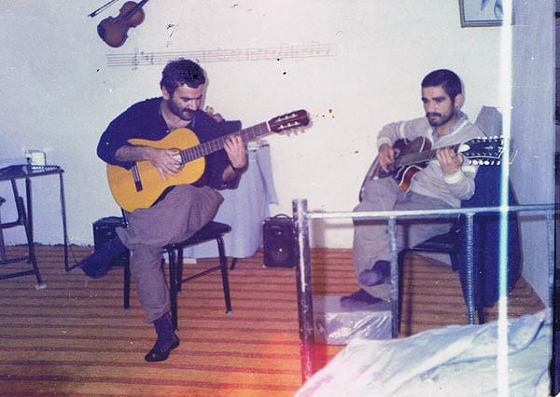
Fariborz Fakhari and Reza Yousef Beigi, Rojhalat (Iranian Kurdistan), 1960s
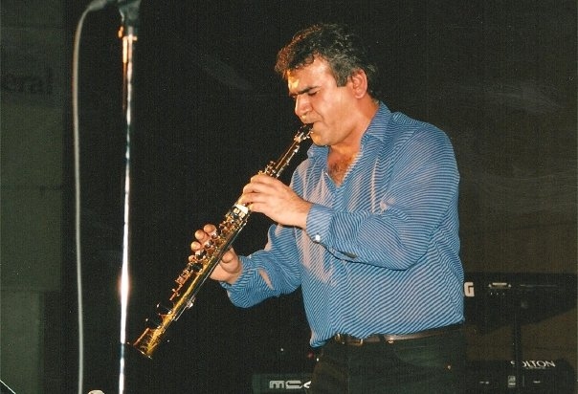
Fariborz Fakhari. Date Unknown.
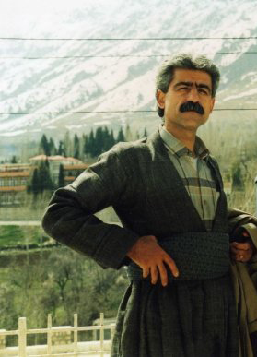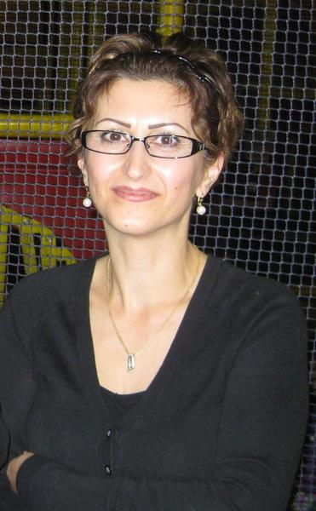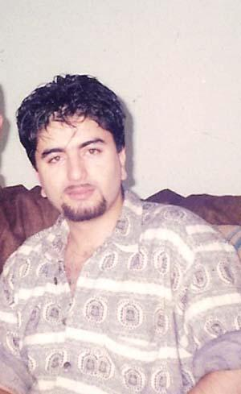
Nasser Hesami, Fermisk (Shabnam) Ahmadi, and Kawe. Date unknown.
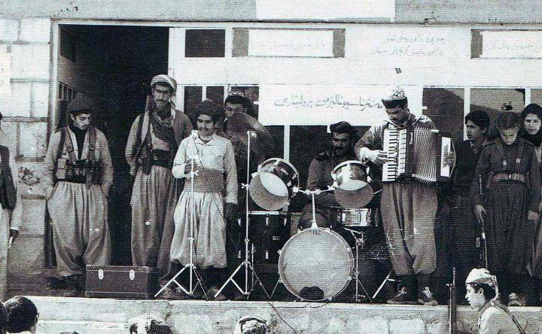
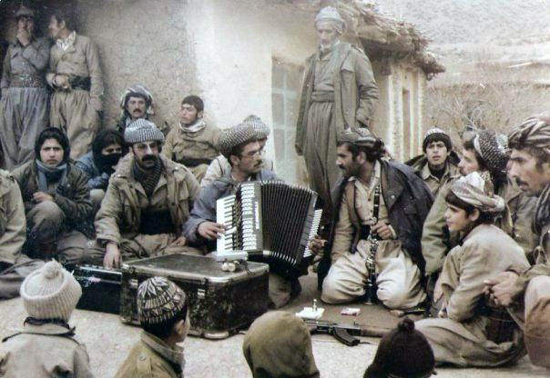
In an interview titled “Revolutionary Kurdistan” with the Communist Party of Iran Fariborz Fakhari, Reza Yousef Beigi, and Fermisk (Shabnam) Ahmadi explain the story of Bangewaz during the events of the Iranian revolution. Before the formation of Bangewaz, a smaller musical ensemble known as Hana operated under the leadership of Fariborz Fakhari, who served as the group's composer. According to Fakhari, Hana was created “as an endeavor to merge with the momentum and enthusiasm of the populace.” The band even performed a public concert in March 1979, but it was soon disbanded after attacks in Kurdistan by the Islamist forces with some of its members moving to Iraqi Kurdistan and joining the Peshmerga, a Kurdish word that translates to “those who face death,” often used to refer to the military forces of the autonomous region of Iraqi Kurdistan, as well as the Kurdish armed forces in other regions. What came from Hana was Bangewaz, meaning “invitation” in Sorani Kurdish, established in 1982 with little to no resources. In his interview, Fakhari explains that he wanted to make music that “resonated with the experiencing situations of people” and how he aimed to make music that was embodied in “movement, passion for life, hope, and not surrendering.” This segment features a selection of tracks translated from Sorani Kurdish and Persian, accompanied by an analysis of the lyrical content in order to shed light on the artistic conventions employed by Bangewaz.
Kokab-e Akhtarha - The Coming Star
The lyrics of Kokab-Akhtarha were written by “Mam Reza,” described by Reza Yousef Beigi as “a pseudonym for an individual who was Persian and had a taste for art.” The melody in the song is a fusion of two prominent melodies that originate from Soviet Russia. These include “Moscow Nights,” which was originally composed by Vasily Solovyov-Sedoi in 1955, and “Song of the Plains,” which was initially composed by Lev Konstantinovich Knipper in 1933. The song is in Persian with Yousef Beigi serving as the vocalist.
لاله گلگون گشته افزون اکنون
دیو زمستان باشد از آن ترسان
پرشده صحرا از غرش و غوغا
بر بهاران دیده ی من تابان
Tulips have flourished, abundant now
The demon of winter, be fearful of that
The desert has become filled with clamor and tumult
My eyes have witnessed the arrival of spring
The lyrics are urging the “demon of the winter” to be afraid of the arrival of the Spring. In this context, Spring is a metaphor for the coming revolution and the liberation of the people. What was once a “desert” is filled with “clamor and tumult” signifying the awakening of nature, being the people.
در افق بشکفته باز،شکوفه های خورشید
کوه و دشت و آسمان،دریا دریا
پر ز موج خنده گردید
Blossoms of the sun have opened on the horizon
Mountains, valleys, the sky, and the sea
Are all laughing with waves of joy
آمد آمد بنفشه در بستان
ابر سیه برچید از افق دامان
بنگر شب از باران کوکب را
اختر باران در دل شب یاران
The violet has arrived in the garden
The black cloud has spread its veil from the horizon
Look at the night and the raining stars
The raining stars in the hearts of friends in the night
بگذشته دی کهنه جهان شد طی
سال نوین و فردای نو در پی
بادا نوروز یاران من پیروز
صدها اخگر در سینه تان هر روز

Mndalani Bi Naw-o Nishan - The Unnamed Children
The poetry used in this track is a Kurdish translation of “Children of the Depths” by Nasser Hesami. Written in 1975, the original piece was written by Ahmad Shamlou, one of the most prominent and influential poets of contemporary Iran, who is characterized by his modernist literary techniques, preoccupation with existentialist themes, and incorporation of mundane imagery. The melody used in this song is an original piece composed by Fariborz Fakhari.
لە شارێ بێ خیابان دا کە ورە دە بن
لە راهیله ی لا کولان و کوچە ی تە نکی بە ستراو دا
ئاوێتە ی دووکە لی کورە و قاچاخچی یە تی و رە ردە برین
چە ن دە س کە لا لە گیرفاند و قوچه قانی بە دە سته وە

They soar in the street-less city
Potty-trained in the narrow alleys and dead ends,
Immersed in the smoke of furnaces and contraband, they express pain.
How many hands beside their pockets and arms in their hands.

The poem is centered around the experiences of stray and disadvantaged children. Despite the absence of a defined street structure they possess adeptness in navigating and maneuvering through the city. The “smoke of furnaces and contraband” may represent the oppressive and exploitative nature of their society.
مندالانی بێ ناو و نیشان ، مندالانی نیو قولکە کان
The unnamed children, without a name or a trace, the children amidst the depths.

لیتە جاری چارە نوسی بێ بە رە یێ لە پیشیان و
جنیوێ باوکانی ماندو لە دووریان
ئفریئێ دلیکائێ وە رە ر لە کوی یان دا و
هیچ لە هیوتر لە میە ینی لە مشتیان دا
The swamp of merciless fate ahead of them,
The curse of the tired fathers behind them,
The curses of their mothers in their ears,
With no hope or future in their fists

The mention of “mother” and “father” indicates the weight of the struggle that is being felt by the younger generation, who are inheriting the generational trauma of poverty. The phrase “no hope or future in their fists” suggests that regardless of their best efforts, they are unable to break free from their circumstances and that they are powerless in the face of the situation.

منداڵانی بێ ناو و نیشان ، مندالانی نیو قولکە کان

The unnamed children, without a name or a trace, the children amidst the depths.

Krikarîn - The Workers
Written by Maslah Seikh Ala-Islami, under the name Rebwar, Krikarîn tells the story of the workers and the proletariat. This form of narrative and terminology is expected of Komala as by the end of the revolution, the organization was largely credited for workers' strikes throughout Iran and Iranian Kurdistan, including a mass strike in production factories in Isfahan and several other companies in Bokan, Iranian Kurdistan.
كریكارین كریكارین
We’re the workers
په‌روه‌رده‌ی ره‌نج و ئازارین
شه‌ پولی لافاوی ئه‌ یار
ئیمه‌ ین ده‌ریای خروشی كار
We’re the educators of suffering and pain,
Waves of the storms of May,
We’re a sea of busy work

سوسیالیسمه ئاسوی ئاوات
ئا سوی ئاوات و روژهه‌لات
Socialism is the way to aspirations
The aspirations of Rojhalat

چه‌رخی روژگار ئه‌ سورینین
تووی ئازادی ئه‌ چینین
We turn the wheel of time
Planting seeds of freedom
نه‌ك هه‌ر لیره‌ له گشت جیهان
هه‌ل ده‌كه‌ین ئالای شورشمان
Not only here, all around the world
We will raise our revolutionary flag

به‌لین ئه‌ده‌ین به‌لینی سوور
له گشت كارگای نزیك و دوور
We promise the red promise
In all factories near and far
ئاگری خو داگرسینین
ریشه‌ی زولم و زور ده‌ردینین
We will light our fire
To the roots of pain and oppression

The music production of Bangewaz stays true to its Kurdish identity, although some songs were sung in Persian, the majority of their music is also composed and sung with original Sorani Kurdish lyrics. The vocalist, Reza Yousef Beigi, later relocated to Turkey and eventually settled in Canada, intermittently pursuing his musical career. Meanwhile, the composer Fariborz Fakhari immigrated to Sweden. Bangewaz’s music continues to be broadcast on the radio stations of Komala and the Communist Party of Iran, with its lyrics alive in the collective memory of Kurdistan. The poetry, melodies, and themes presented by Bangewaz exhibit a distinct regional character, marked by unique features that are not commonly found elsewhere. While the music reveals some traces of external influence, it remains vastly autonomous from outside forces.

CONCLUSION
Through a comprehensive examination of the lyrics, historical background, and contextual framework surrounding the production of these cassette tapes, this research has been able to offer a valuable contribution to filling a significant gap in the sensory history of the Iranian Revolution. The profound significance of these cassette tapes and their role in the Marxist history of Iran remain understudied and underrepresented in academic discourse, making the systematic study of their contents and production a crucial undertaking. Through exploring the complexities of the music, the associations, and the messages conveyed in these cassette tapes, a deeper understanding of the culture and the art of student activism in Iran can be attained, and the artistic contributions of the student movements can be given the recognition they deserve. The story of Iranian student activism did not reach its zenith in 1968, although the student movement abroad found its roots in the New Left, the movement ultimately only grew stronger in force and remained independent of the larger context of Third World Internationalism.
While studying the culture and history of Iranian student activism of the 1960s and the 1970s, the scholarly conversation has fallen short in studying and examining the music production and cassette circulation of the movement. The study of music production by leftist students in Iran deserves equal attention to other forms of artistic and political expression. Moreover, limiting the Iranian student movement's affiliation solely to Third World Internationalism fails to recognize the agency, autonomy, and ingenuity of Iranian students, and thus does an injustice to their multifaceted contributions to the movement. The existence of the unique music production in Mazandaran and Kurdistan proves that the cassette tapes of these political groups are a result of the dedication to the grassroots mobilization of Iranian students. While Iranian students abroad were in touch with solidarity movements of Third World Internationalism, their counterparts within Iranian borders created their own revolutionary music that clearly communicated the political stance of the composition and sense of urgency for action. When comparing the material of these three musical groups, it is apparent while CISNU draws inspiration from the New Left, Sorkheh Roja found its identity in its traditional and commonly known folklore, and Bangewaz articulated its musical expression through the language and cultural associations of the Kurdish people. Nonetheless, all the cassettes created by Sorkheh Roja, CISNU, and Bangewaz are revolutionary and an integral part of the contemporary history of Iranian music.

Andrew Nash, “Third Worldism,” African Sociological Review 7, no. 1 (2003): p. 95.
Afshin Matin-Asgari, “The ‘Resurrection of the Iranian Nation,’” in Both Eastern and Western: An Intellectual History of Iranian Modernity (Cambridge, United Kingdom: Cambridge University Press, 2018), p. 235.
Peyman Vahabzadeh, “Organization of Iranian People’s Fadai Guerrillas,” in A Guerrilla Odyssey: Modernization, Secularism, Democracy, and the Fadai Period of National Liberation in Iran, 1971-1979 (New York, NY: Syracuse University Press, 2010), p. 18.
Peyman Vahabzadeh, “Organization of Iranian People’s Fadai Guerrillas,” in A Guerrilla Odyssey: Modernization, Secularism, Democracy, and the Fadai Period of National Liberation in Iran, 1971-1979 (New York, NY: Syracuse University Press, 2010), p. 19.
Gholamreza Nejati, Tarikh-e siyasi-ye bistopanj saleh-ye Iran. [The twenty-five- year political history of Iran] (Tehran: Rasa Cultural Services, 1992), p. 383.
Naqi Hamidian. Safar bar balha-ye arezu [A voyage on the wings of a dream]. (Vällingby, Sweden: Arash Förlag, 2–4), p. 28.
Nahid Siamdoust, in Soundtrack of the Revolution: the Politics of Music in Iran (Stanford, CA: Stanford University Press, 2017), p. 325.
Peyman Vahabzadeh, “Organization of Iranian People’s Fadai Guerrillas,” in A Guerrilla Odyssey: Modernization, Secularism, Democracy, and the Fadai Period of National Liberation in Iran, 1971-1979 (New York, NY: Syracuse University Press, 2010), p. 30.
Kar [OIPF-M] 1995, p. 8.
Quoting from “Payam-e Fadayi”, the publication of the guerrillas of the People's Fedayeen of Iran, issue 264, July 2021.
ILNA. “Shajarian of Mazandaran: Obituary and Legacy.” ILNA, 20 February 2020.
Interview with Master Abu'l-Hasan Khoshrou: “Without People, Art Cannot be Created,” in Ermun [Armon], 26 Esfand 1392 [16 March 2014].
Mazandnomeh. “Master Abolhassan Khoshrou's concert was held.” January 17, 2014.
Hamshahri Online. “Zandegi-Name-ye Ahmad Mohsenpour (1324-1394).” Hamshahri Online, 28 December 2015.
Mazandnume. استاد احمد محسن پور درگذشت [Professor Ahmad Mohsenpour passed away]. Mazandnume. January 20 2016.
Sorkheh Roja, “Mashti,” 00:38.
Sorkheh Roja, “Mashti,” 01:45 to 02:00.
Afshin Matin-Asgari, “Origins of the Student Movement in Iran and Abroad to 1960,” in Iranian Student Opposition to the Shah (Costa Mesa, CA: Mazda Publishers, 2002), p. 29.
Afshin Matin-Asgari, “Origins of the Student Movement in Iran and Abroad to 1960,” in Iranian Student Opposition to the Shah (Costa Mesa, CA: Mazda Publishers, 2002), p. 29-30.
Afshin Matin-Asgari, “Origins of the Student Movement in Iran and Abroad to 1960,” in Iranian Student Opposition to the Shah (Costa Mesa, CA: Mazda Publishers, 2002), p. 33.
Paul A. Kramer, “Is the World Our Campus? International Students and U.S. Global Power in the Long Twentieth Century,” Diplomatic History 33, no. 5 (November 2009): pp. 775-806, https://doi.org/10.1057/9781137060150.0003.
Victor Bascara, “Unburdening Empire,” in Model-Minority Imperialism (Minneapolis, MN: University of Minnesota Press, 2006), pp. 1-25.
Lisa Lowe, “Immigration, Citizenship, Racialization: Asian American Critique,” in Immigrant Acts: On Asian American Cultural Politics (Durham: Duke University Press, 2007), p. 13.
Lisa Lowe, “Immigration, Citizenship, Racialization: Asian American Critique,” in Immigrant Acts: On Asian American Cultural Politics (Durham: Duke University Press, 2007), p. 27-28.
Claire Jean Kim, “The Racial Triangulation of Asian Americans,” Politics & Society 27, no. 1 (1999): pp. 119-120, https://doi.org/10.1177/0032329299027001005.
Manijeh Moradian, “‘Down with the Shah!": Political Racialization and the Iranian Foreign Student Revolt,” American Quarterly 74, no. 3 (September 2022): pp. 716-719, https://doi.org/10.1353/aq.2022.0050.
Christina Klein, “Introduction,” in Cold War Orientalism: Asia in the Middlebrow Imagination, 1945-1961 (Berkeley, CA: Univ. of California Press, 2009), p. 12.
Manijeh Moradian, “‘Down with the Shah!”: Political Racialization and the Iranian Foreign Student Revolt,” American Quarterly 74, no. 3 (September 2022): p. 717, https://doi.org/10.1353/aq.2022.0050.
Matthew K. Shannon, “Education between Iran and the West,” in Losing Hearts and Minds: American-Iranian Relations and International Education during the Cold War (Cornell University Press, 2017), p. 3.
Mary L. Dudziak, “Introduction,” in Cold War Civil Rights: Race and the Image of American Democracy (Princeton, NJ: Princeton University Press, 2011), pp. 6-8.
Paul A. Kramer, “Is the World Our Campus? International Students and U.S. Global Power in the Long Twentieth Century,” Diplomatic History 33, no. 5 (November 2009): pp. 782, https://doi.org/10.1057/9781137060150.0003.
Afshin Matin-Asgari, “Origins of the Student Movement in Iran and Abroad to 1960,” in Iranian Student Opposition to the Shah (Costa Mesa, CA: Mazda Publishers, 2002), p. 36-37.
Afshin Matin-Asgari, “ Origins of the Student Movement in Iran and Abroad to 1960,” in Iranian Student Opposition to the Shah (Costa Mesa, CA: Mazda Publishers, 2002), p. 39.
Afshin Matin-Asgari, “Introduction,” in Iranian Student Opposition to the Shah (Costa Mesa, CA: Mazda Publishers, 2002), p. 10.
Afshin Matin-Asgari, “The Confederation of Iranian Students/ National Union (1962),” in Iranian Student Opposition to the Shah (Costa Mesa, CA: Mazda Publishers, 2002), p. 50.
Afshin Matin-Asgari, “The Post-CISNU Propaganda War and the Coming of the Revolution (1976-79),” in Iranian Student Opposition to the Shah (Costa Mesa, CA: Mazda Publishers, 2002), pp. 148-162.
Afshin Matin-Asgari, “Introduction,” in Iranian Student Opposition to the Shah (Costa Mesa, CA: Mazda Publishers, 2002), p. 2.
Hamid Shawkat Collection, “CISNU Congress Reports 1965-1977” (Stanford, CA: Hoover Institution Library and Archives, 2010).
Arang Keshavarzian, Ali Mirsepassi, and Manijeh Moradian, “Iranian Diasporic Possibilities: Tracing Transnational Feminist Genealogies from the Revolutionary Margins,” in Global 1979 Geographies and Histories of the Iranian Revolution (Cambridge, United Kingdom: Cambridge University Press, 2021), pp. 106-107.
Afshin Matin-Asgari, “Calling for the Regime’s Overthrow and the Final CISNU Split,” in Iranian Student Opposition to the Shah (Costa Mesa, CA: Mazda Publishers, 2002), p. 135.
Elizabeth Marie Ennenga (2020), p. 51.
Ibid., 37-39.
Cheh nabayad kard (Communist Unity Group: 1977), 23-25.
lran-e azad no. 84 (August 1972), no. 87 (October 1973), and no. 89 (February 1974).
lran-e Azad, nos. 87-89 (October 1973 to February 1974), 91-92 (September 1974 to March 1975); Bakhtar-e emruz, nos. 51-52 (March 1974 and April 1974); Kargar, vol. 6, no. 7 (December 1973) and no. 9 (September 1974).
Afshin Matin-Asgari, “Calling for the Regime’s Overthrow and the Final CISNU Split,” in Iranian Student Opposition to the Shah (Costa Mesa, CA: Mazda Publishers, 2002), pp. 144-145.
Afshin Matin-Asgari, “Calling for the Regime’s Overthrow and the Final CISNU Split,” in Iranian Student Opposition to the Shah (Costa Mesa, CA: Mazda Publishers, 2002), pp. 146-147.
Mohamman Amin Mahmoudpour, “سعید سلطانپور، شاعر انقلاب,” مجله هفته , January 5, 2014, https://web.archive.org/web/20140605060305/http://www.hafteh.de/?p=44629.
Bijan Baran, “پیدایش سرود سراومد زمستون ,” Eshterak, June 13, 2012, www.eshtrak.wordpress.com/2012/06/13/پیدایش-سرود-سراومد-زمستون-دکتر-بیژن-با/.
Faranj Sarkohi, “جنگ چریکی هنر و ادبیات، خنجی خونین بر چهره‌ ناباورِ آبی,” Persian BBC News (BBC, February 3, 2011), https://www.bbc.com/persian/iran/2011/02/110128_l13_siahkal_part_one.
سازنده آلبوم "شراره‌های آفتاب" سخن می‌گوید, Justice For Iran (Justice For Iran, 2018), https://justice4iran.org/persian/reports/sharareh-haye-aftab/.
Baran, Mehrdad. شراره های آفتاب، یاد ها و خاطره ها. Other. Radio Payam. Radio Payam Canada, September 1, 2018. www.radiopayam.ca/شراره-های-آفتاب،-یاد-ها-و-خاطره-ها/.
Bijan Baran, “پیدایش سرود سراومد زمستون ,” Eshterak, June 13, 2012, www.eshtrak.wordpress.com/2012/06/13/پیدایش-سرود-سراومد-زمستون-دکتر-بیژن-با/.
سازنده آلبوم "شراره‌های آفتاب" سخن می‌گوید, Justice For Iran (Justice For Iran, 2018), https://justice4iran.org/persian/reports/sharareh-haye-aftab/.
Peyman Vahabzadeh, “Organization of the Iranian People’s Fadai Guerrillas (1971–1979),” in A Guerrilla Odyssey: Modernization, Secularism, Democracy, and the Fadai Period of National Liberation in Iran, 1971-1979 (Syracuse, NY: Syracuse University Press, 2010), pp. 25-30.
Nahid Siamdoust, “The Politics of Music,” in Soundtrack of the Revolution: The Politics of Music in Iran (Stanford, CA: Stanford University Press, 2017), p. 18.
Gross, Joel. “Street Theatre in Revolutionary Iran.” Third World Quarterly 4, no. 2 (1982): 491-500. doi: 10.1080/03064228208533450.
Cronin, Stephanie. “Importing Modernity: European Military Missions to Qajar Iran.” Armies and State-Building in the Modern Middle East, 2014. https://doi.org/10.5040/9780755608553.ch-002.
Hashem Ahmadzadeh and Gareth Stansfield, “The Political, Cultural, and Military Re-Awakening of the Kurdish Nationalist Movement in Iran,” The Middle East Journal 64, no. 1 (January 2010): pp. 11-12, https://doi.org/10.3751/64.1.11.
David McDowall, “The Kurds in the Age of Tribe and Empire,” in A Modern History of the Kurds (London: I.B. Tauris, 2021), p. 76.
Hashem Ahmadzadeh and Gareth Stansfield, “The Political, Cultural, and Military Re-Awakening of the Kurdish Nationalist Movement in Iran,” The Middle East Journal 64, no. 1 (January 2010): p. 13, https://doi.org/10.3751/64.1.11.
Nishtiman, Vol. 1, No. 1 (July 1943)
Archie Roosevelt, “The Kurdish Republic of Mahabad,” Middle East Journal 1, no. 3 (1947): pp. 247-269, https://doi.org/http://www.jstor.org/stable/4321887.
David McDowall, “Ethno-Nationalism in Iran,” in A Modern History of the Kurds (London: I.B. Tauris, 2021), pp. 245-246.
Sada Tekoshan, p. 15. This d
Ali Ezzatyar, “Introduction,” in Last Mufti of Iranian Kurdistan: Ethnic and Religious Implications in the Greater Middle East (London: Palgrave Macmillian, 2018), p. 34.
Sabah Mofidi, “The Left Movement and National Question: From Romanticism to Realism (With a Focus on Komala Organization),” Journal of Ethics and Cultural Studies 3, no. 1 (2016): pp. 20-48, 30.
Ali Ezzatyar, “Sunni, Shia, and Kurd: A Brief History of Islamism in Kurdistan,” in The Last Mufti of Iranian Kurdistan: Ethnic and Religious Implications in the Greater Middle East (New York, NY: Palgrave Macmillan, 2016), p. 35.
Ali Ezzatyar, “Sunni, Shia, and Kurd: A Brief History of Islamism in Kurdistan,” in The Last Mufti of Iranian Kurdistan: Ethnic and Religious Implications in the Greater Middle East (New York, NY: Palgrave Macmillan, 2016), p. 35.
IBID BUT I NEED ACTUAL SOURCE LISTED CAUSE NO ONE HAS ACTUALLY SOURCED THIS RIGHT
Sabah Mofidi, “The Left Movement and National Question: From Romanticism to Realism (With a Focus on Komala Organization),” Journal of Ethics and Cultural Studies 3, no. 1 (2016): pp. 20-48, 32.
Entessar, Nader. The Mafia of Power: Studying the Racial-Ethnic Nationalism of Kurds. Translated by Erfan Taherifard. 1st ed. Tehran, Iran: 2007, 474.
Karimi, Ali. The Life and Memoir of Abdurrahman Zabehi (Mamosta Olama). 2nd ed. Slemani, Iraqi Kurdistan: Ministry of Culture and Youth, 2005.
Mohammadzadeh, Khalid (2007). “An interview with Saed Watandust,” retrieved, 2007/2/9, from: www.Dimane.com.
Sabah Mofidi, “The Left Movement and National Question: From Romanticism to Realism (With a Focus on Komala Organization),” Journal of Ethics and Cultural Studies 3, no. 1 (2016): pp. 20-48, 37.
Mohammadzadeh, Khalid (2007). “An interview with Saed Watandust,” retrieved, 2007/2/9, from: www.Dimane.com.
Mohammadzadeh, Khalid (2007). “An interview with Saed Watandust,” retrieved, 2007/2/9, from: www.Dimane.com.
Interview with the Communist Part of Iran. Fariborz Fakhari, Reza Yousef Beigi, and Fermisk Ahmadi.
Interview with the Communist Part of Iran. Fariborz Fakhari, Reza Yousef Beigi, and Fermisk Ahmadi.

